**Text-to-Speech Adventure**

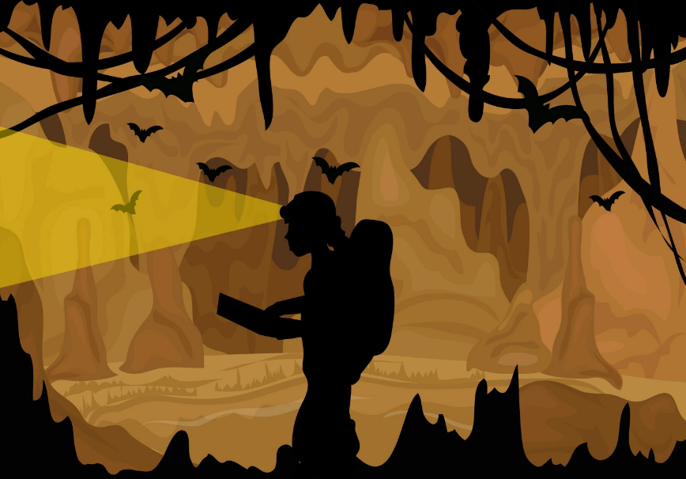Senior Project  
System Manual

Mujeeb Adelekan

[madelekan@mail.stmarytx.edu](mailto:madelekan@mail.stmarytx.edu)

Spring 2022

Contents

Overview 1

Analysis and Requirements 8

Design 11

Installation 33

Sample Sessions 38

Troubleshooting 47

References 50

Source Code File Listings 53

Overview

The following is an overview of my senior project, beginning with a discussion of the problem, my motivation, some background solutions, my solution, and the benefits.

**Problem/Issue**

Human-computer interaction needs to offer options to as many users as possible. Unfortunately, hardware and software manufacturers are prone to ignoring the needs of the visually impaired. This extends to gaming, a medium where interactivity is paramount to user experience. Although the video game industry has made great strides in terms of accessibility in recent years, including adaptive controllers and extensive accessibility options, many game developers still overlook the needs of players with different sensory and motor abilities than themselves.

**Motivation**

I am fascinated by alternative methods of controlling video games. Methods of input, through controllers or otherwise, and feedback to user input, are the most important aspects of game design. I admire Nintendo for their innovations in the control methods of their consoles, from the directional pad in their Game-and-Watch line, to the analog control stick in the Nintendo 64 controller, to the motion controls implanted in the Wii Remote. However, these advancements come at a price.

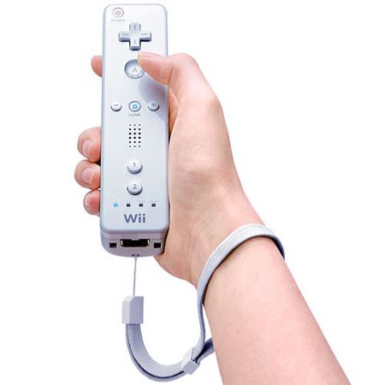Several years ago, I read an IGN article by a Nintendo fan who had to come up with alternative methods of holding and interacting with the controller due to his motor impairments. Although the author conceded that the technique was not ideal, it was enough to allow him to enjoy the games to the best of his ability. However, a new challenge presented itself when the Wii was revealed. While the rest of the gaming community, and the media at large, was enamored by the novelty of swinging a controller like a tennis racket to do perform the action in-game, the author felt worried and displaced. The Wii was a revolution in game control, but to him, it was the opening of an already significant rift being him and his favorite medium.

I also read a story of a Japanese fifth-grader who mailed a letter to the the development team of Nintendo’s game series Rhythm Heaven. This title is a rhythm-action game in which the player must respond to audio cues to succeed. The player wrote in their letter that they were grateful to be able to enjoy the game even though they were blind.

Stories like these made me realize that there is still a barrier between gaming and players who require alternative means of input. I want to study the domain of accessibility in games and develop a product that helps bridge the accessibility gap.

**Background**

Since gaming is a medium driven by input and feedback, game companies have experimented with alternative methods of control since the early days of the industry. Japanese video game company Nintendo developed a neck harness accessory for their Famicom console (known in the west as the Nintendo Entertainment System) that allowed the player to control a game with their chin or lower lop. However, these early attempts at alternative control, or adaptive technology, were little more than a novelty. Many of these initiatives held a lower priority than the goal of establishing and maintaining a strong platform and brand presence.

In the last decade, adaptive technology became increasingly prevalent in the gaming industry, despite the perceived ambivalence of government regulators. In 2010, the United States Congress passed the Video Communications Act. Although the act regulates accessibility in TV, radio, and movies, among other media, it overlooks video gaming. This prompted independent organizations to advocate for accessibility in gaming and develop innovations that expand the medium to those who were left out.

One such organization is AbleGamers. Steven Spohn, the Chief Operating Officer of AbleGamers, said in an interview with gaming news website NintendoLife that AbleGamers “is a humanitarian charity”, one that is focused on the “social output” of gaming. Spohn, who suffers from spinal muscular atrophy (SMA), a disease that causes muscles used for movement to weaken and deteriorate, stated that for the first few years of AbleGamers’ existence, the biggest hurdle was convincing both those within and those outside the gaming industry that accessibility in gaming was a legitimate issue to begin with. Throughout the past decade, however, AbleGamers have “moved from advocacy to action,” said Spohn.

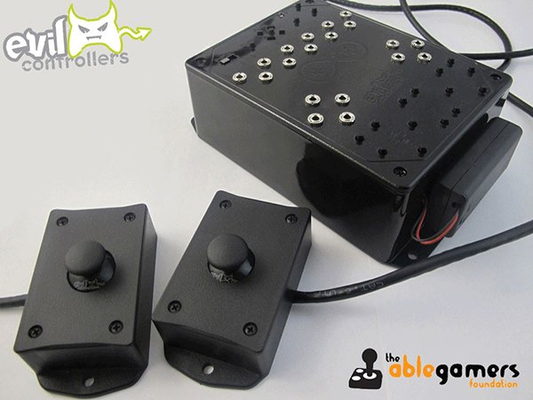In 2011 AbleGamers collaborated with Evil Controllers to develop the Adroit Controller. Designed for the Xbox 260, the Adroit Controller was the first accessibility switch-based controller to be produced. AbleGamers’ work on the Adroit Controller would set the groundwork for their collaboration with Microsoft that would result in the creation of the Xbox Adaptive Controller, released in 2018 (shown on the cover of this proposal).

Microsoft has continually worked to make their Xbox gaming platform more accessible to those with disabilities. Anita Mortaloni, the Director of Accessibility at Xbox, said the number one question she sees form consumers is “What game can I play?” In 2016, Xbox added the option to give assistive tech to Xbox Avatars, which are virtual representations of the players. As of the writing of this proposal, Xbox is rolling out a Game Accessibility Tag system that displays what features are present in a game (e.g., “Narrative Game Menus”, “Input Remapping”, “Single Stick Gameplay”, etc.)

However, there is still work to be done. Although the Xbox Adaptive Controller offers assistance for those with motor disabilities, those with visual or hearing disabilities still seek more options. Furthermore, the XAC only works with Xbox and Windows devices, thus making those devices the only ones with a dedicated controller for accessibility. Tara Voelker, the Accessibility Lead of Xbox Game Studios, stated that the gaming industry needs to form inter-corporate partnerships to combat feature exclusivity issues like the XAC’s limited device compatibility.

In addition to user input, accessibility must be considered in the design of the game itself. One example of an often-overlooked accessibility design principle is to put accessibility settings at the *start* of a first-time game launce, rather than hiding it in the settings. One particularly egregious violation of this principle occurs in the 2019 Nintendo Switch game Pokémon Sword and Shield, which has its closed captioning options locked behind “hearing buds” the player collects in an optional side quest.

To advance accessible game design, AbleGamers runs the Player Panel Program, a body of hundreds of players with disabilities who advise the video game industry. AbleGamers also hosts *accessible.games,* a website dedicated to accessible player experiences, or APX. This website offers a Certified APX Practitioner course that trains developers to adopt a new “APX language” for game design. For example, the issue of a player clicking a button may lead to the wrong button being pressed. To remedy this, the designer can implement a way to undo a mistake. APX would call this “undo-redo”, Spohn said.

Great milestones in accessibility have been made in mainstream gaming. Controller remapping, for example, is considered a standard practice in games as closed captioning is to movies. In fact, the 2021 game Dungeons & Dragons: Dark Alliance received controversy for its lack of control remapping. Other advancements include the 2012 game Borderlands 2 adding a colorblind mode at the requests of players and the 2021 game Forza Horizon 5 adding a myriad of accessibility features like game speed modification, high contrast mode, a screen reader, and an option to disable moving backgrounds.

When it comes to relaying environmental information to a blind player, one of the most effective means is through audio descriptions. Reading a script to a blind player with hearing ability is a great way to help the player form an image of the scenario. Richard Bartle, a developer who creates games of the text-based genre interactive fiction (IF), stated that although our senses filter information and graphics create a “model”, text speaks directly to the imagination. Bartle reinforced that despite the advancements of graphics, in terms of player experience, “the farthest you can go is text.”

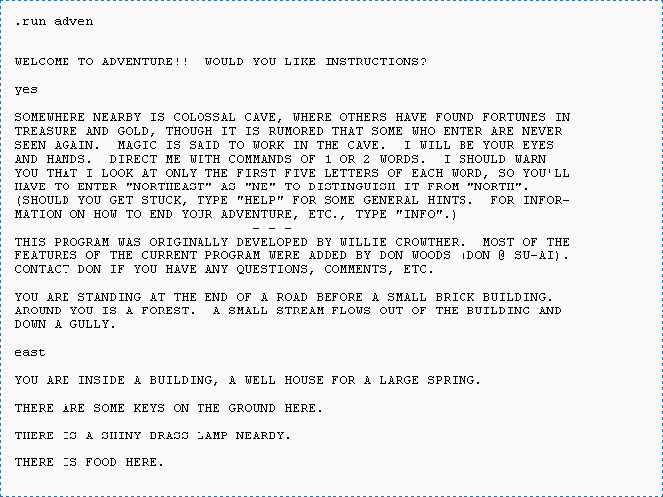The documentary *Get Lamp* stated that IF explores the power of words in an interactive context. That is, IF can be considered virtual reality that exists in words. What is considered the first IF game, 1975’s Colossal Cave Adventure, was inspired by creator Will Crowther’s spelunking activities. Writing an IF game, like spelunking, involves both atmospheric description and objective, scientific bearing. Zork, created in 1977 by MIT students, was the first major IF game to allow full sentences. The popularity of Zork (later referred to as Zork I to distinguish the title from its sequels) led to the finding of IF developer Infocom, whose titles found great success in the early to mid-80s. Even though the ear of commercial IF companies is long dead, over 2,000 new works have been created since and an active homegrown IF community persists to this day.

IF can be and has been enjoyed by blind players. *Get Lamp* displayed a blind user playing Zork with a speech synthesizer. The documentary interviewed Debee Norling, another IF fan who is blind, and she claimed that playing IF is “playing at being sighted." The blind players in Get Lamp emphasized the importance of creating a sense of objects in addition to providing a sense of place and movement. IF allows the player to explore a world with sight, described as “liberating” by player Austin Seraphin.

Despite the entertainment IF can bring to blind players, according to IF developer Aaron Reed, expanding accessibility of IF is not prioritized due to the medium’s niche modern audience. This is an issue I intend to help remedy.

**Solution**

Text-to-Speech Adventure is a text adventure I created in the style of the 1977 game *Zork,* but the text is read using Microsoft Narrator to assist blind players. It is a room-based adventure in which the player will navigate through exits and solve simple puzzles to escape the dungeon. Tailoring the text descriptions to blind players, each room is described with care put into the spatial relationships and textures of objects as well as the temperature of the environment. When brainstorming for this project, I assumed that object descriptions outside of texture would be of less importance, but after doing research I realized that equal consideration must be put into creating a sense of object. In order to eliminate the chance of the player entering in an action that is not valid, the game offers the player up to four options at any given moment, with each option mapped to the D, F, J and K keys. The option is then confirmed by pressing the Space bar. Room and scenario data is stored in a relational database managed by Microsoft SQL Server Management Studio 2018 and queried by the main program module. Text-to-Speech is a Windows console application written in C# in Visual Studio Community 2019 and developed on a Windows 10 machine.

**Benefits**

Text-to-Speech Adventure allows both sighted and visually impaired players to enjoy the same game. By using Microsoft Narrator, blind players can process the options given to the player as well as the results of the actions the player has taken. The text descriptions will have blind players build mental maps of the environment and their bearing in relationship to the exits and objects in each room. Since IF is an on-rails genre, inactivity can be controlled to what the designer wants the player to do. This can be used to reduce confusion, as is the case with this game limiting the player to four options. Having the user use the D, F, J, and K keys along with the Space bar simplifies controls by locking them to five keys that are part of the “neutral” typing position.

Consider the case of a new player. Once the player launches the game, the game will return the description of the starting room along with the actions the user will take. The screen reader will read the description, list the actions, then give the user directions on how to select an option and then confirm that action with the Space bar. The results of that option are then displayed immediately.

Analysis and Requirements

The following section includes an outline of my analysis process for Text-to-Speech Adventure. This is following by a listing of the requirements of Text-to-Speech Adventure and an overview of the product’s functionalities.

**Analysis**

For my analysis of Text-to-Speech adventure, I had to think about how information should be relayed to a blind person and how blind people should interface with the program. I chose spoken text as a medium to describe the game’s world to a blind person, yet that led to another issue. How can the world be described to a blind person? Certain characteristics of objects that sighted people take for granted (i.e., the color of objects) will be ineffective. Furthermore, over-describing details of objects may lead to a loss of comprehension by a player who has no visual experience of said descriptions. That said, being too vague will create the same problem. A happy medium of detail must be considered when creating the text descriptions. As stated in the overview, a sense of object is ultimately as important to a blind person as a sense of place and movement.

Even though it is not wise to assume that *all* blind people are able to reason visually, we are able to take advantage of the fact that blind people more than often perceive the world in “spatial” means. That is, the positional relationships between objects will play a major factor in how the text descriptions are written.

The input problem is interesting since there are various input options for blind people, including the standard keyboard. What is fascinating about the keyboard is that to be a developed typist one must solidify the spatial relationships of the keys. Very rarely do developed typists look down at the keyboard. We are trained to think about all keys in relation to the ASDF row on the keyboard. The Space bar is also prominent enough so the typist can “code-switch” between their thumbs and other fingers, making it easy to remember where the Space bar is.

This input analysis led to the idea of using the D, F, J, K and Space keys as input for the program. The Q key is also used to quit the program.

**Requirements**

The following are the requirements need for users and developers, respectively.

**Hardware and Software for a User**

Text-to-Speech is designed to run on a Windows 10 machine. The application is designed for sighted and visually impaired users who have basic English reading or listening ability, and motor ability that allows for use of a traditional keyboard (including Braille keyboards).

Hardware requirements:

* Windows machine
  + Intel/AMD/Nvidia Processor
  + Minimum Disk Space: 12KB
* Mouse, Keyboard, and Monitor

Software requirements:

* Operating System: Windows 10 or later

Player requirements:

* Basic English reading or listening ability
* Motor ability that allows for use of a traditional keyboard

**Hardware and Software for a Developer**

Text-to-Speech Adventure is a Windows console application written in C# in Visual Studio Community 2019. Development was done on a Windows 10 machine. Room data is stored in a relational database that is managed using Microsoft SQL Server Management Studio 2018.

Hardware requirements:

* Windows machine
  + Intel/AMD/Nvidia Processor
  + Minimum Disk Space: 12KB
* Mouse, Keyboard, and Monitor

Software requirements:

* Operating System: Windows 10
* Code Editor/IDE: Visual Studio (2019 or newer) or Notepad
* Programming Language: C#
* Database Management Software: Microsoft SQL Server Management Studio 2018

**Functionalities**

The following are the user and system functionalities of Text-to-Speech Adventure:

The system will:

* Display text on screen
* Read text aloud for visually impaired or blind players
* Read all actions the player can take
* Allow the user to select up to four options at any point in the game
* Repeat a selected option so the user can confirm their choice
* Take keyboard input (D, F, J, K, Q keys and Space Bar
* Store conditions and text descriptions in a database
* Store unique data for each scenario
  + Room description
  + Room name
  + Options for the scenario
  + The resulting scenario of each option

The user will:

* Listen to an audio description of the scenario
* Press D, F, J, or K to select an option
* Press Space to confirm an option
* Press Q to quit the game

Design

The following is an overview of the design process for Text-to-Speech Adventure. A database containing a description for every scenario along with the at most four options and the resulting scenario for each option will be queried to at run time.

**Environments**

Here the development environments of Text-to-Speech Adventure will be discussed. Text-to-Speech Adventure is written C# in Visual Studio Community 2019 on a Windows 10 machine. I chose C# since it is an object-oriented language, allowing me to build the game system in a modular fashion. I am more familiar with Visual Studio than any other IDE, and the same goes for Windows among operating systems. The game is developed as a Windows Console application, ensuring that it runs on all Windows 10 machines.

The relational database is created using MS SQL Server Management Studio 2019. Database creation and queries are designed using SQL since I am familiar with it and C# allows for SQL integration.

**Data Structures**

Text-to-Speech Adventure works with a database that stores Room and Scenario data. The development and design of the database will be discussed. First, the schema will be discussed with a visual showing the relationship between the two tables. Then, a discussion regarding how the database functions with example data from the final project will be given.

Room Database Schema

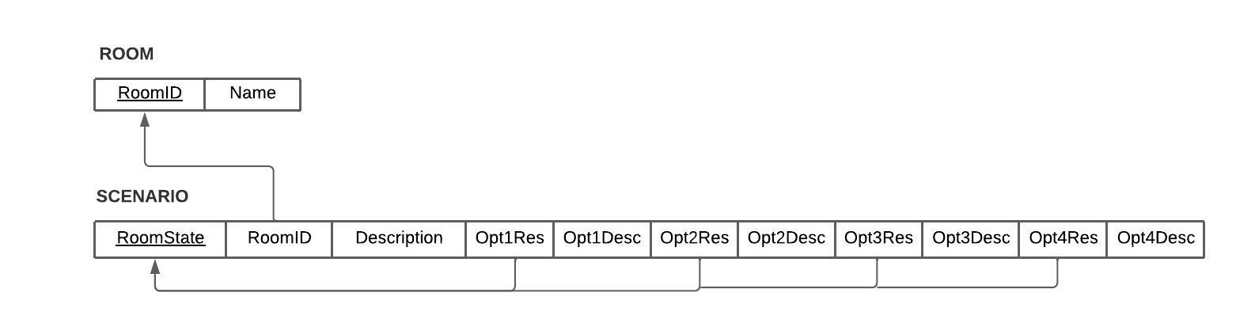

Above is the final schema for the Room Database. The schema consists of the names and column headers of the database along with arrows representing foreign keys (the arrowhead pointing to the primary key that is referenced by the foreign key). The foreign keys of SCENARIO are Opt1Res, Opt2Res, Opt3Res, and Opt4Res (where “Opt” is short for option.) and RoomID. Since the options are foreign keys from RoomState, the options correspond to new room states. That is, if an option is chosen, the game updates to the room state value associated with that option. Note that this choice of primary and foreign keys makes SCENARIO a self-referential entity.

The ROOM table exists for normalization purposes. Each room in the game is given a unique RoomID that is referred to in SCENARIO.

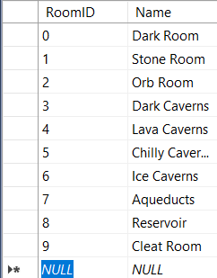Snapshots of the Room Database

Above is the ROOM table as it appears in the Room Database. There are 10 rooms in the game, each with its own RoomID. The game notifies which room the player is in by querying the Name through the RoomID of the current RoomState in SCENARIO.

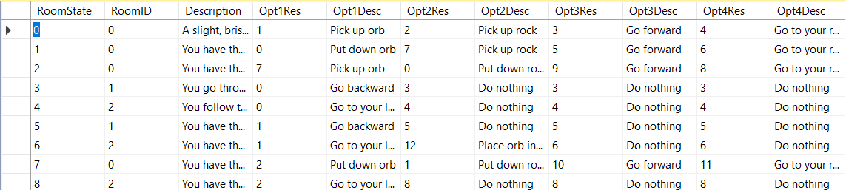

Above are the first nine entries of the SCENARIO table as it appears in the Room Database. When the player launches the game, they start at RoomState = 0 (the first row). As previously mentioned, the RoomID is used to query the name of the current room. The description of the current scenario is displayed on screen. The four options are description in Opt1Desc, Opt2Desc, Opt3Desc, and Opt4Desc. In game, this actions correspond to the D, F, J, and K keys respectively. Selecting and confirming an action will updated the RoomState to that options corresponding result (Opt1Desc corresponds to Opt1Res, Opt2Desc corresponds to Opt2Res, and so on)

For example, if the user chooses option 2 by pressing F then hitting the space bar while RoomState = 0, the game will update the current scenario to Opt2Res, which in this case is 2. As such, RoomState will now equal 2, and along with that change comes a new description and new options. Note, however, that the RoomID is the same as it was when RoomState = 0 (namely, RoomID is still 0), meaning that the player has not changed rooms (i.e., the player is still in the Dark Room).

**Software Modules**

Since C# is an object-oriented programming language, the software modules of the Text-to-Speech Adventure system will represent classes. There are three major classes in the system of this game:

1. **GameController:** The central module of Text-to-Speech Adventure. GameController coordinates the game system by being referenced in the other major module, RoomNavigation. It is responsible for controlling what gets displayed/read to the user.
2. **RoomNavigation:** Keeps track of the properties of the current room the player is in. Also determines the results of the actions the player has taken.
3. **Room:** A category of objects that contain room information queried from the database.

Each class contains a particular set of attributes (characteristics) and/or methods (procedures). Each attribute and method will have its C# data type or class written after the colon (:). The attributes and methods of each class are as follows:

1. **GameController**
   1. Attributes
      1. **RoomNavigation : RoomNavigation** – a reference to the RoomNavigation class.
      2. **actionLog : List<string>** -- list of actions the user has taken
      3. **sqlCon :** **SqlConnection** – represents connection to SQL Server database
   2. Methods
      1. **Main() : void** – entry point of the GameController class
      2. **DisplayLoggedText() : void** – display the current contents of the action log.
      3. **AddRoomDescriptionToActionLog() : void** – display the current room’s description by adding it to the action log
      4. **AddToActionLog(actionDescription : string) : void** – add the description of the chosen action to the action log
      5. **GetSQLConnection() : SqlConnection** – get access to the SQL server connection
2. **RoomNavigation**
   1. Attributes
      1. **currentRoom : Room** – holds the room the player is currently in
      2. **controller : GameController** – a reference to the GameController class
      3. **scenario : int** --- current room state the player is in
      4. **options : string [ ]** – array that holds the current options the user can perform
      5. **sqlCon :** **SqlConnection** – represents connection to SQL Server database
   2. Methods
      1. **<<constructor>> RoomNavigation()** – constructor method for the RoomNavigation class
      2. **DisplayOptionsForCurrentScenario(roomState : int)** **: void** --- print the options for the current scenario (room state)
      3. **AcceptInput() : void** --- takes in the integer representation of the option chosen by the user
      4. **RespondToInput(action : int) : void** – will determine the result of the action chosen
3. **Room**
   1. Attributes
      1. **description : string** – holds room’s description
      2. **roomName : string** – hold room’s name
   2. Methods
      1. **<<constructor>> Room()** --- default constructor for Room class
      2. **<<constructor>> Room(description: String, roomName: String)** --- explicit constructor of Room class
      3. **setDescription(description : string) : void** --- setter method for description attribute
      4. **setRoomName(roomName : string) : void** --- setter method for roomName attribute
      5. **getDescription() : string** --- getter method for description attribute
      6. **getRoomName() : string** --- getter method for roomName attribute

**System Structure**

In this subsection, a class diagram of Text-to-Speech Adventure will be presented, followed by a discussion regarding flowchart sketches that drove the development of the game.

Class Diagram

Below is the class diagram of Text-to-Speech Adventure, which organizes the class software modules, attributes, and methods discussed in the Software Modules section. This diagram shows the class names, attributes, methods, and relationships between each class. A plus sign (+) signifies that an attribute or method is public, or visible by other classes. A minus sign (--) signifies that an attribute or method is private, or only visible by the class in which that attribute or method is contained.

The relationships present in the class diagram stand for the following:

* **Bidirectional Association:** Two classes both contain an instance or reference of the other.
* **Directional Association:** One class contains an instance or reference of the second class. The arrowhead points to the class containing the instance or reference.

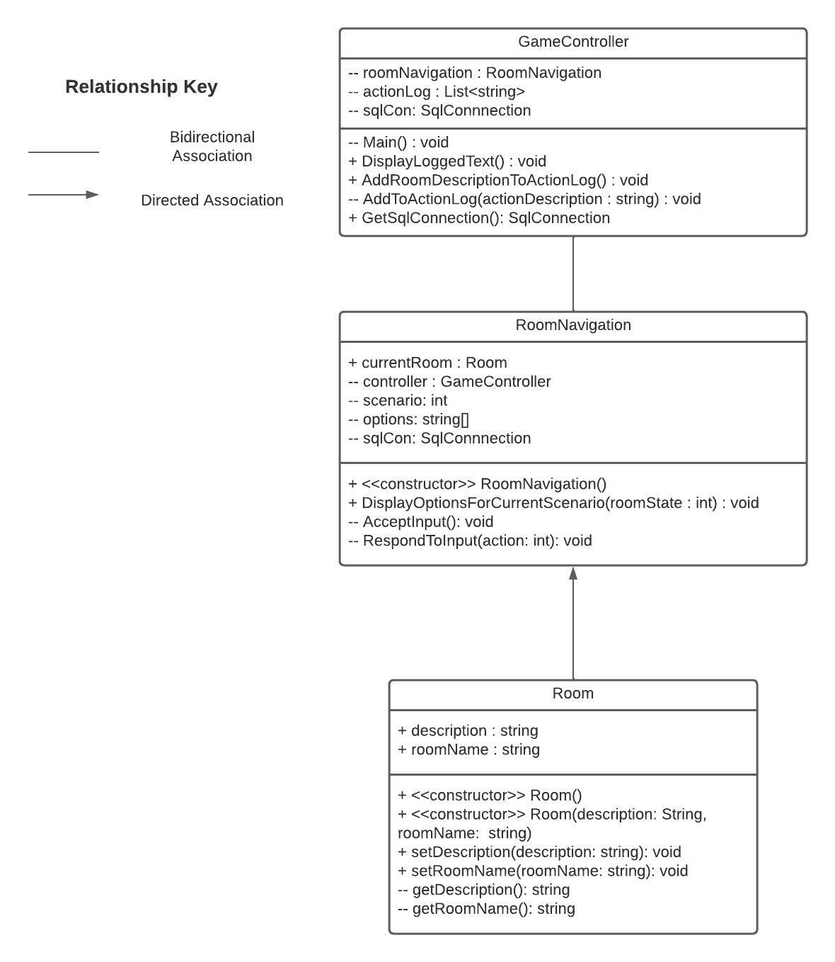

Flowchart Sketches

The following are sketches of flowcharts that were created during development to help account for each scenario the user may find themselves in throughout the game.

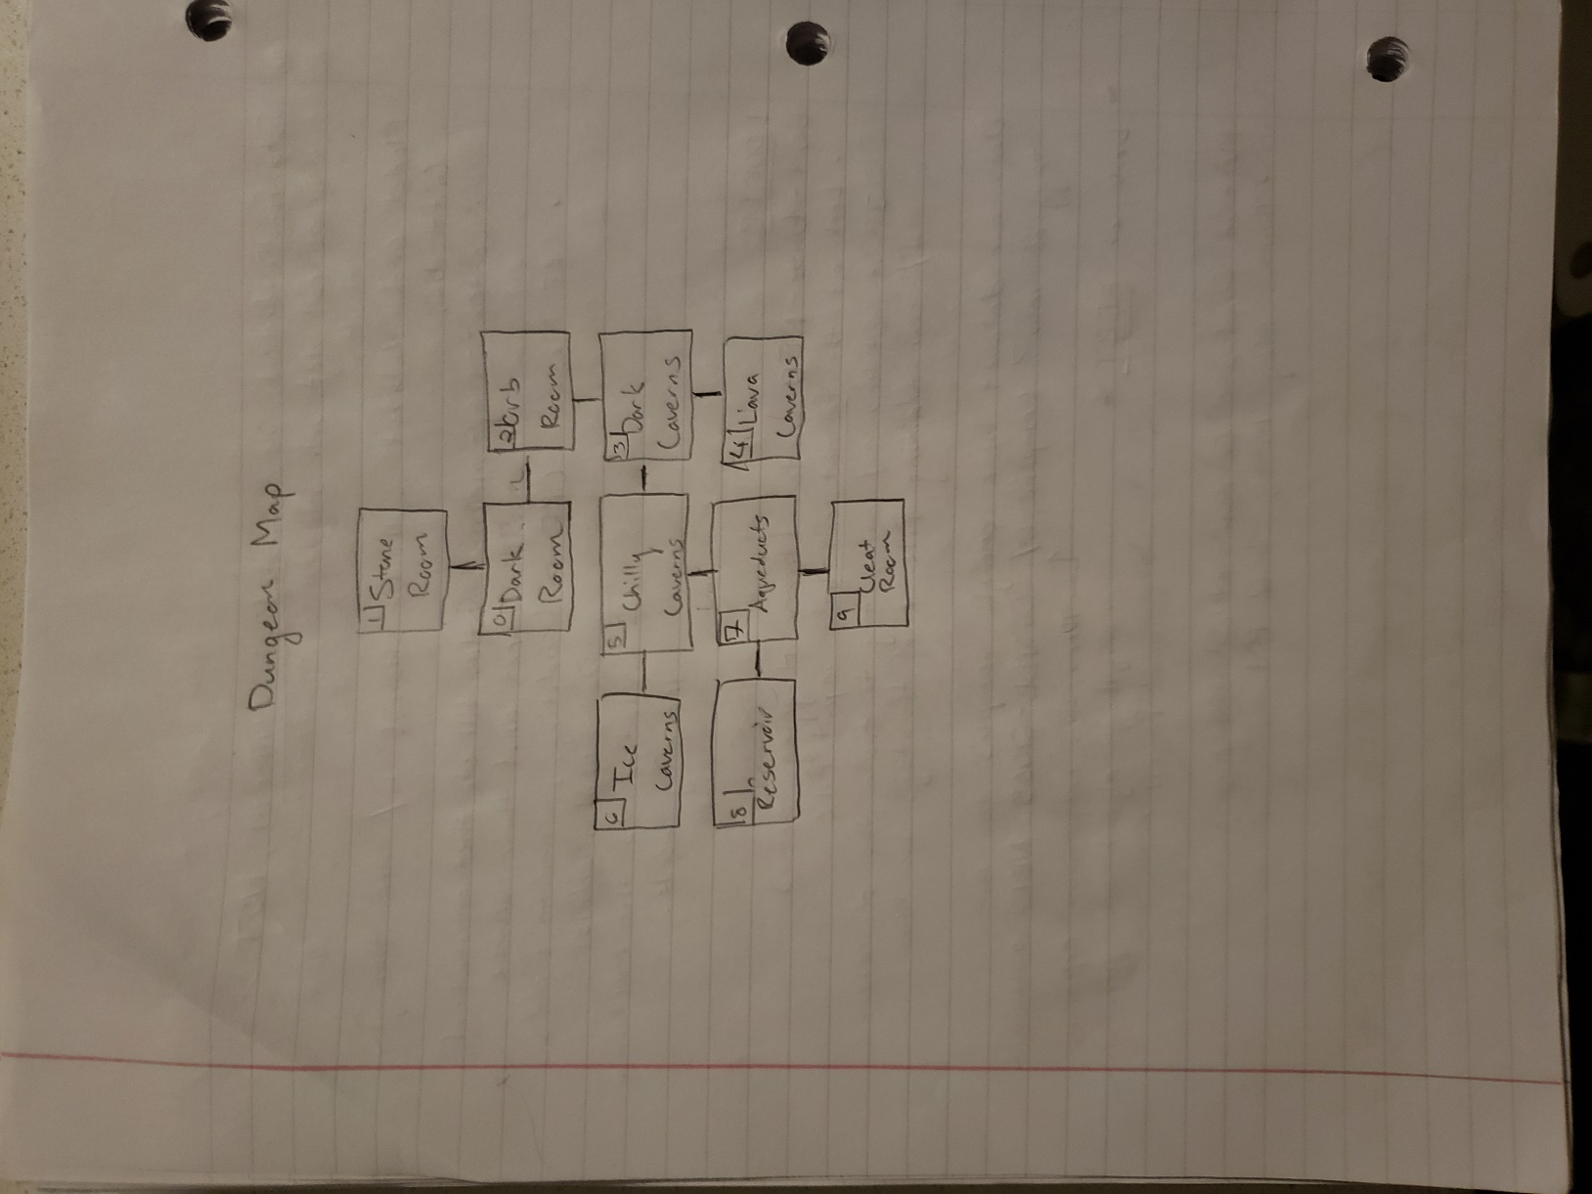

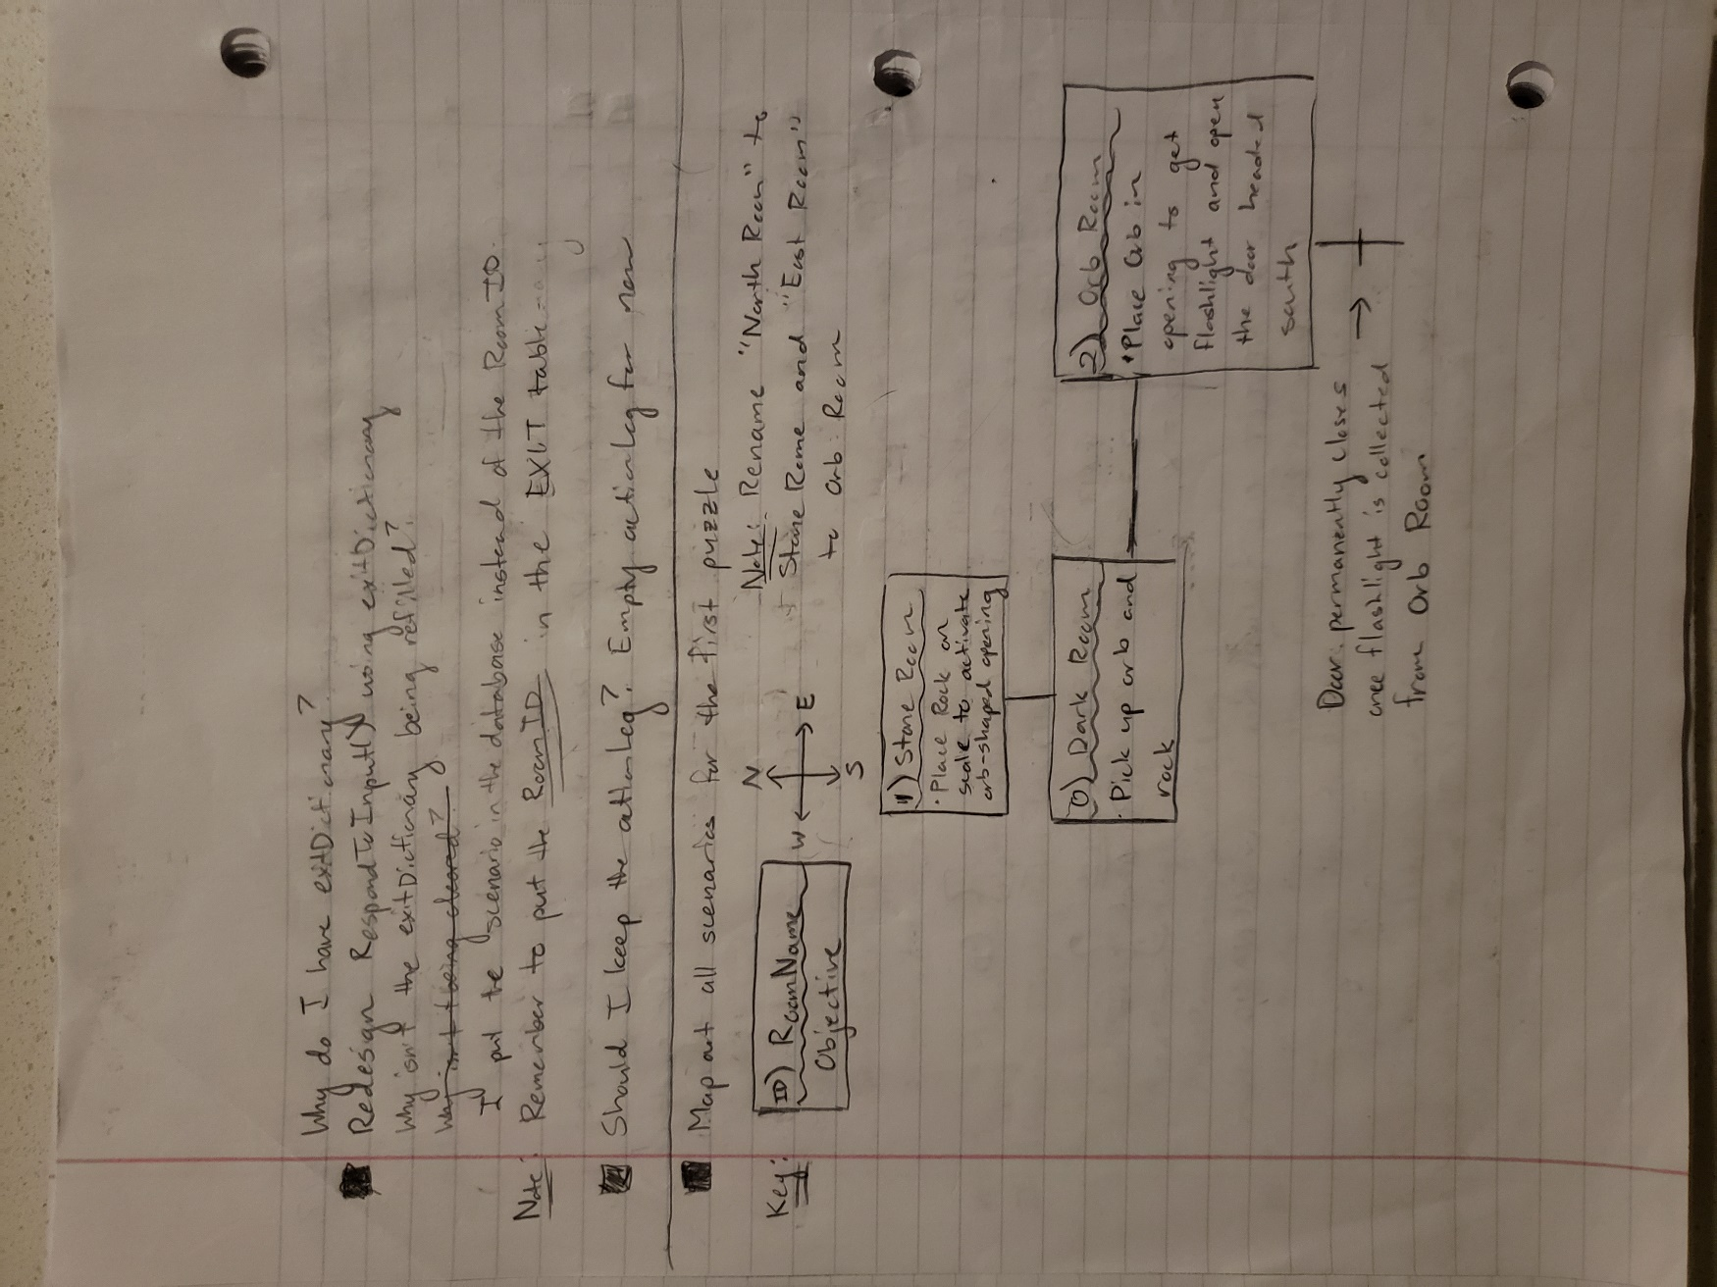

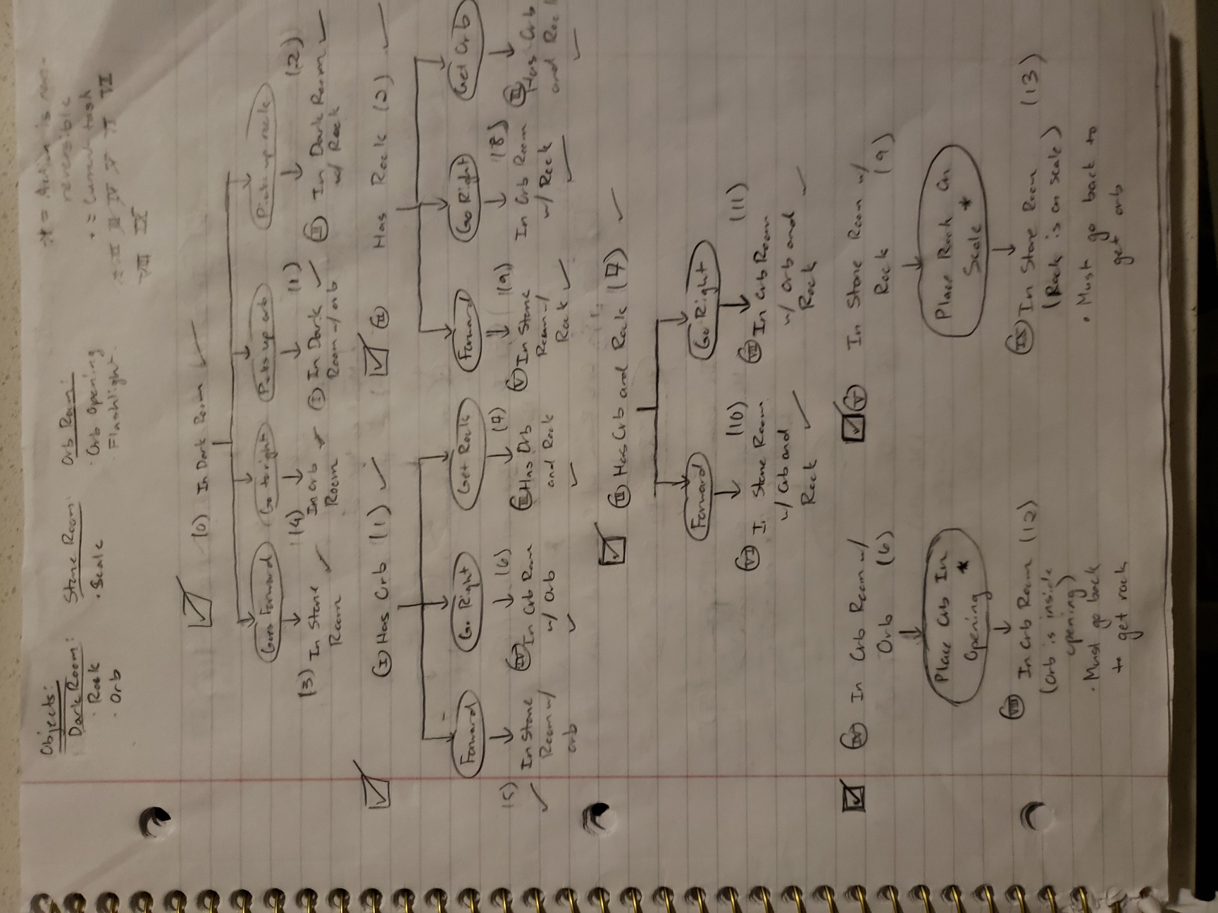

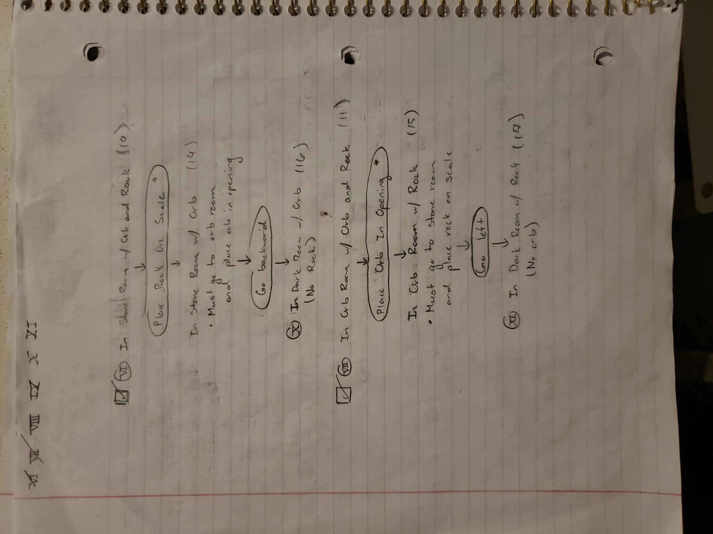

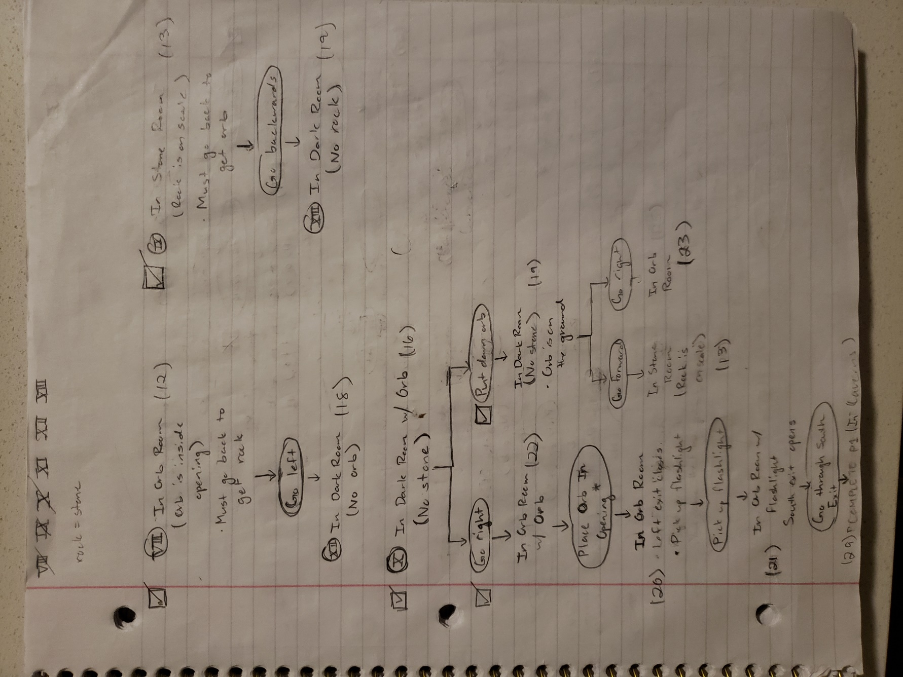

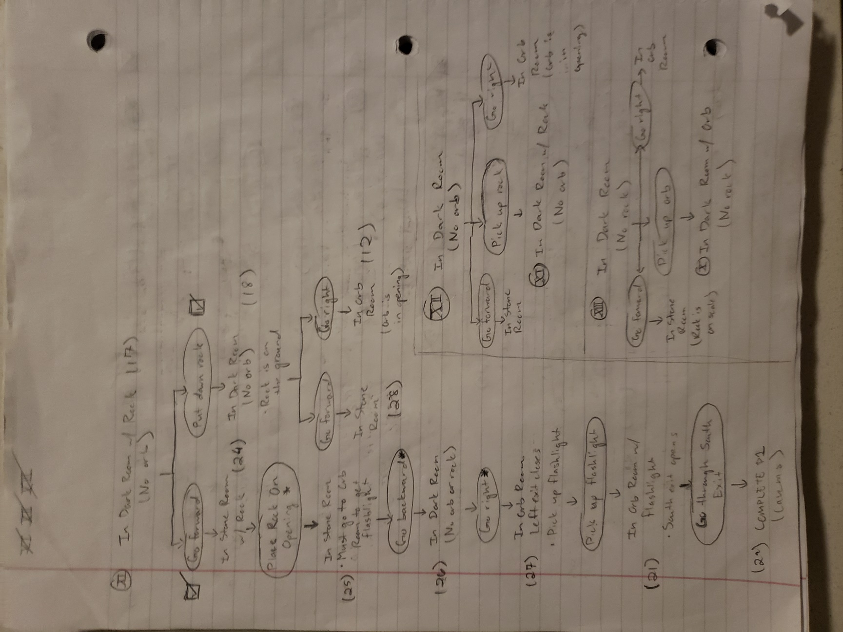

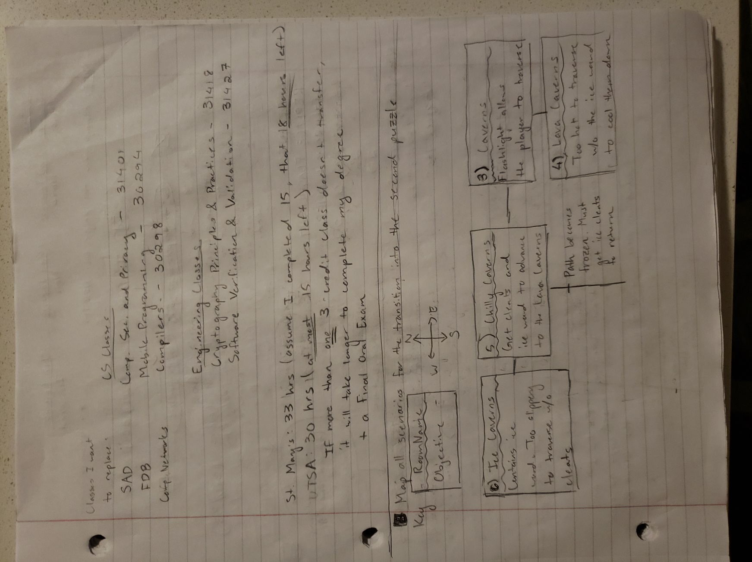

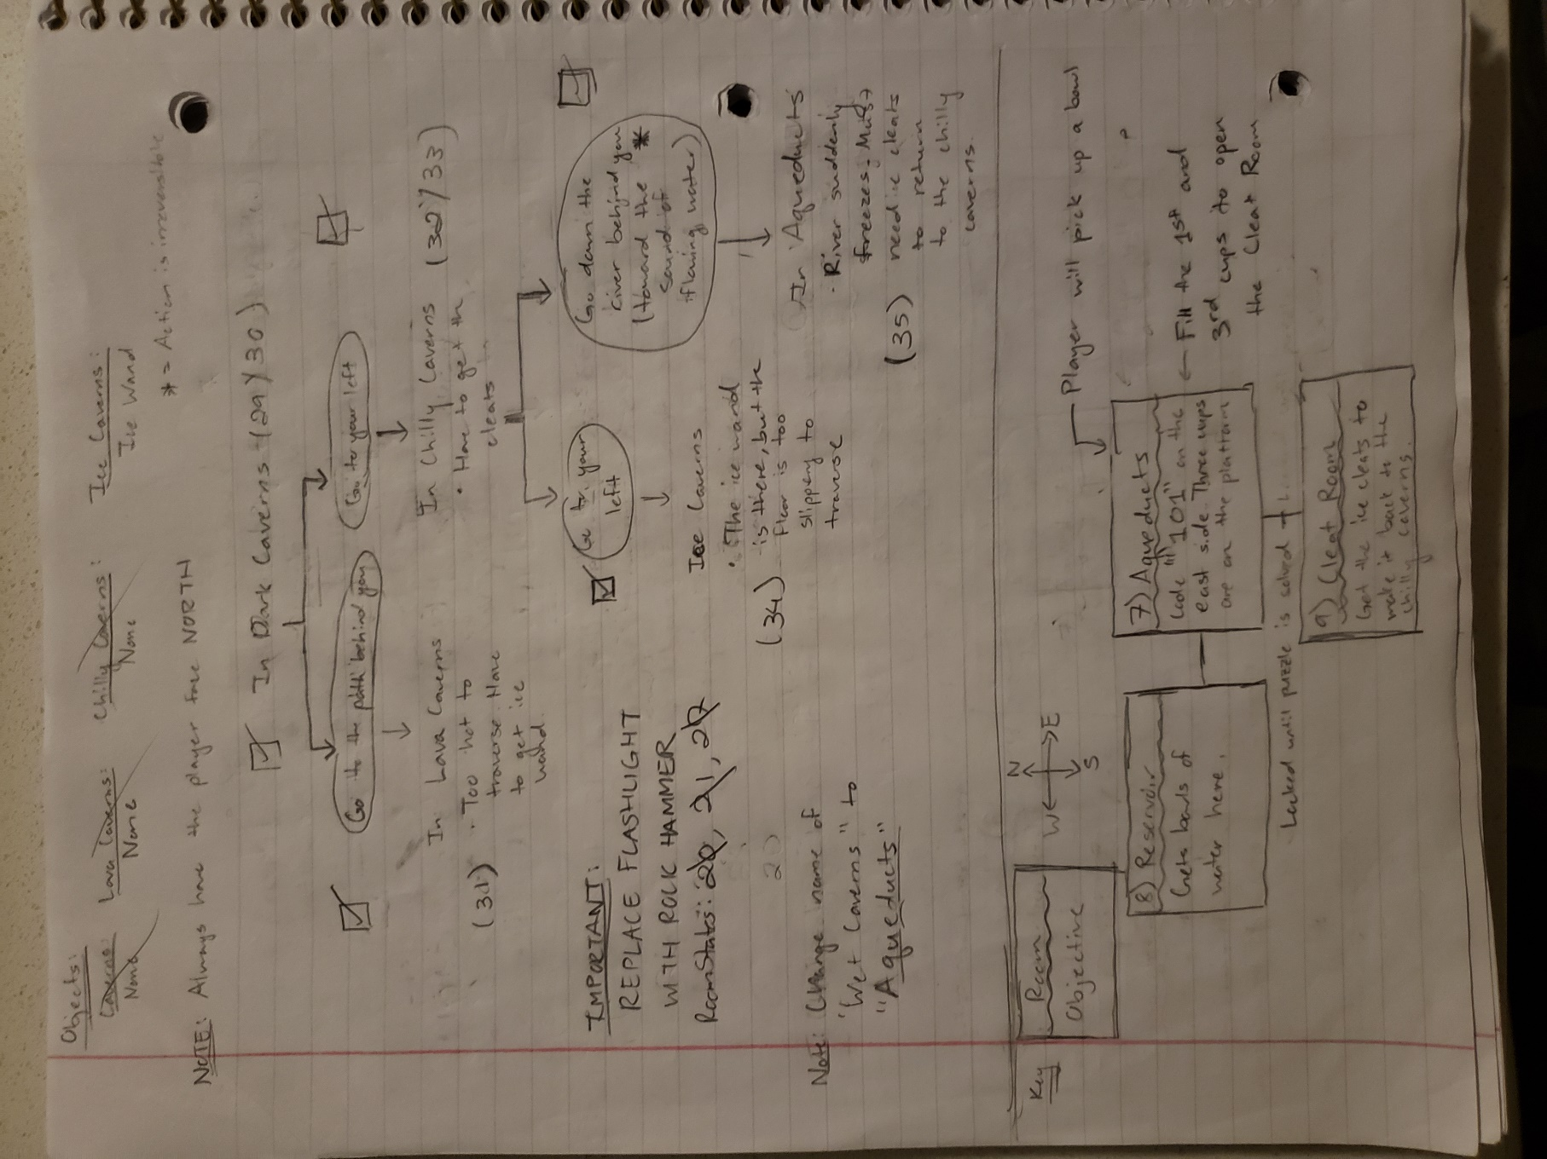

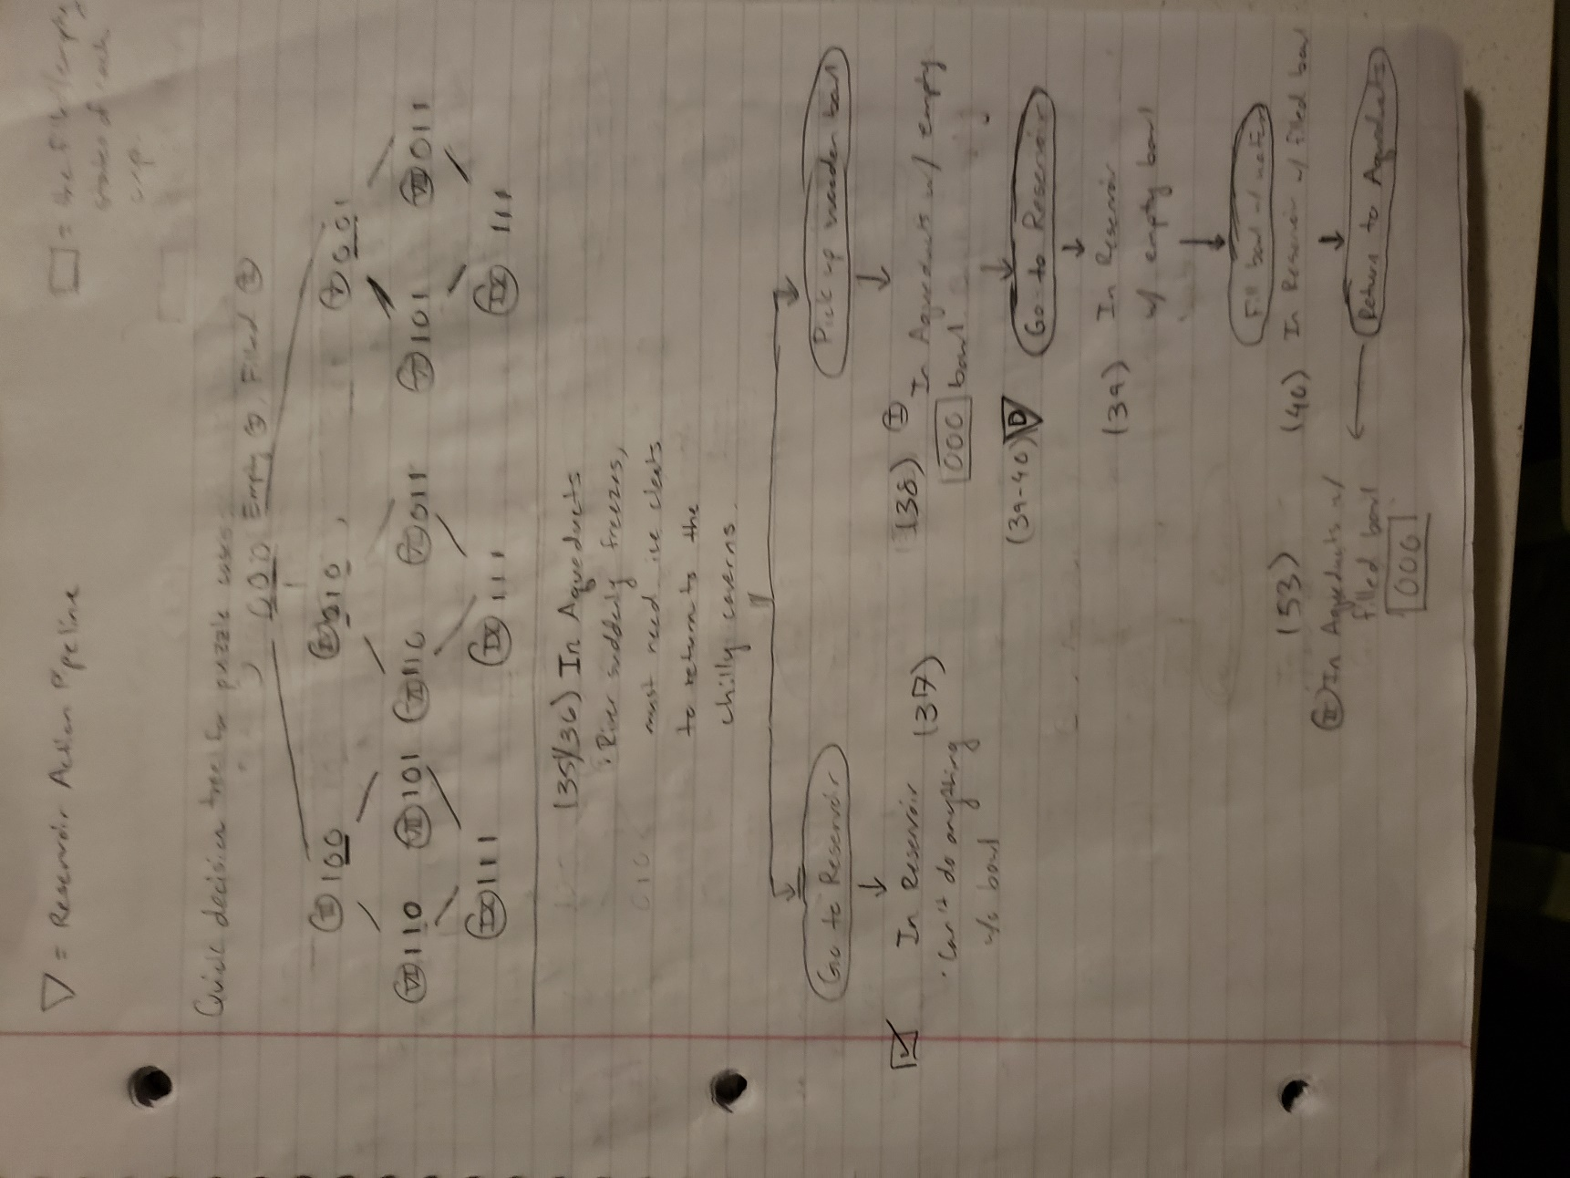

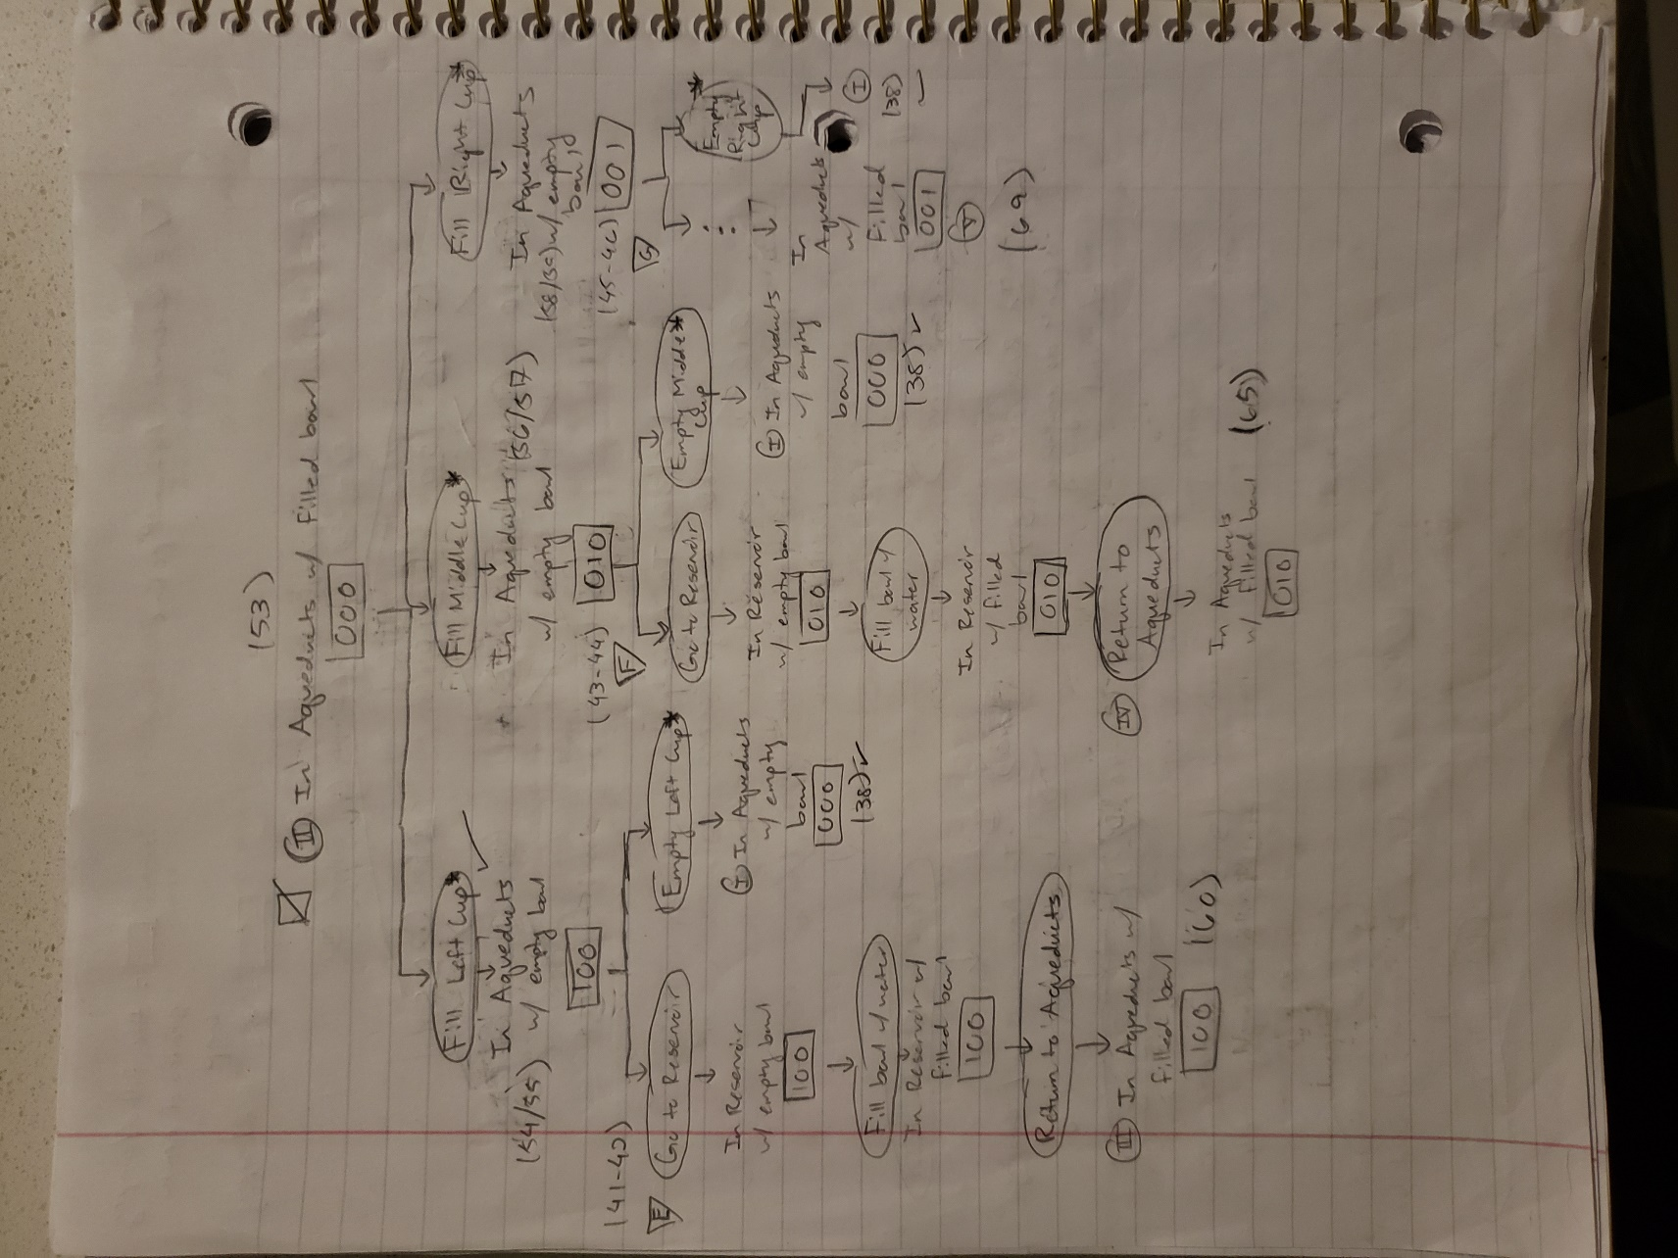

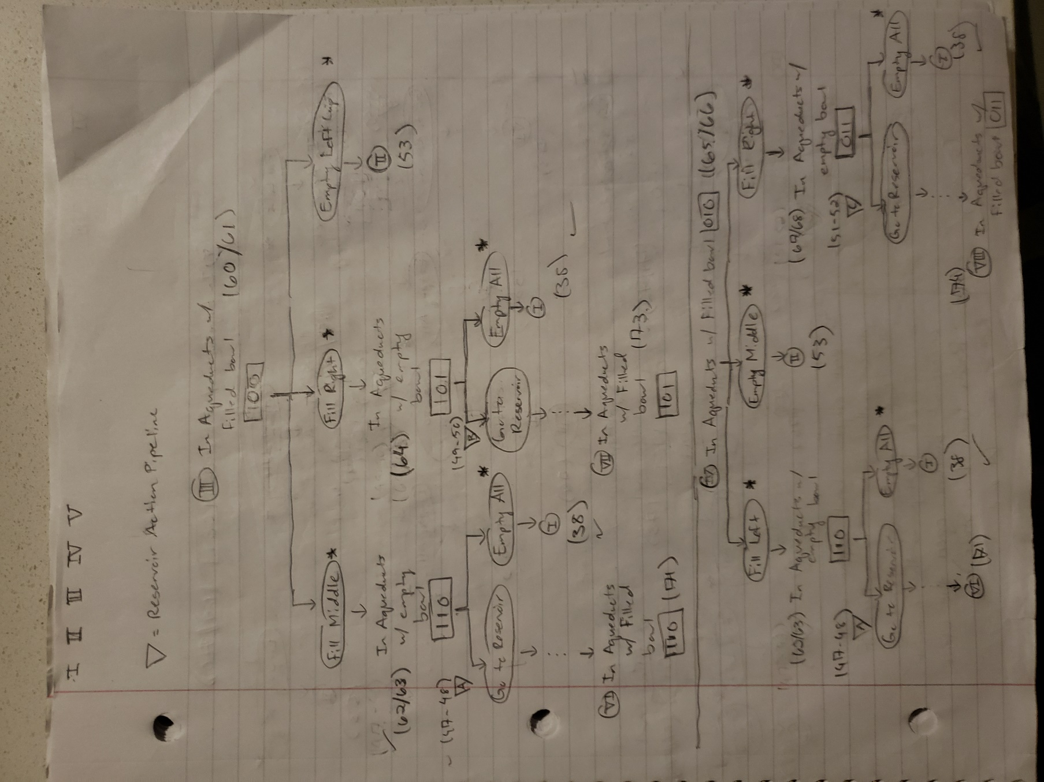

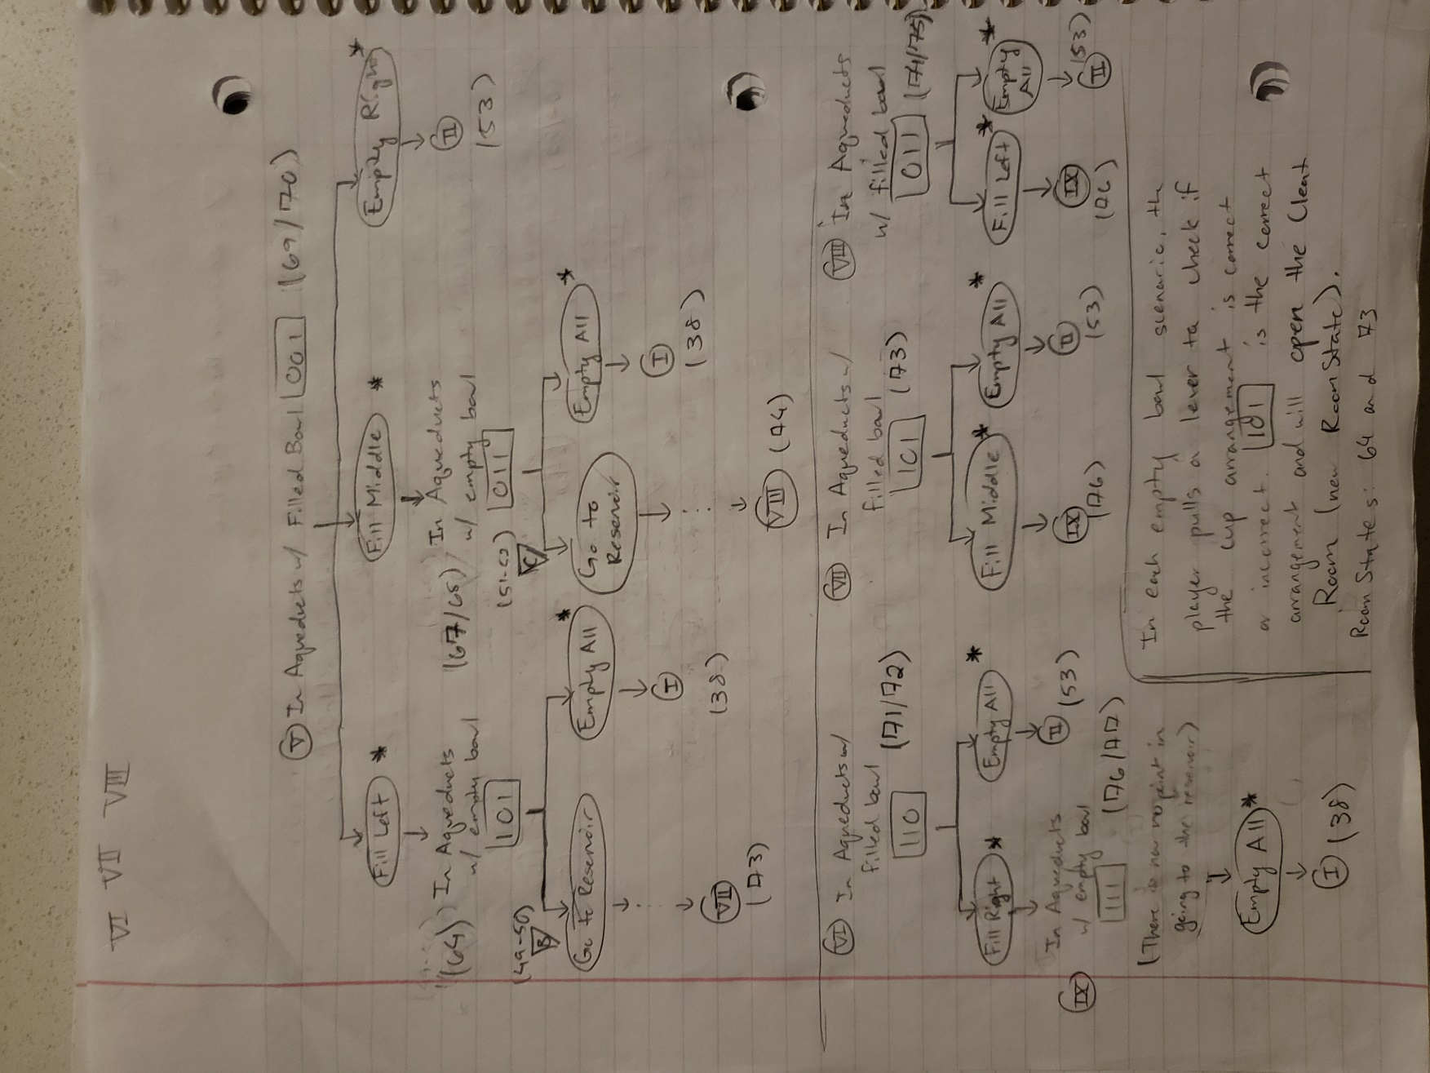

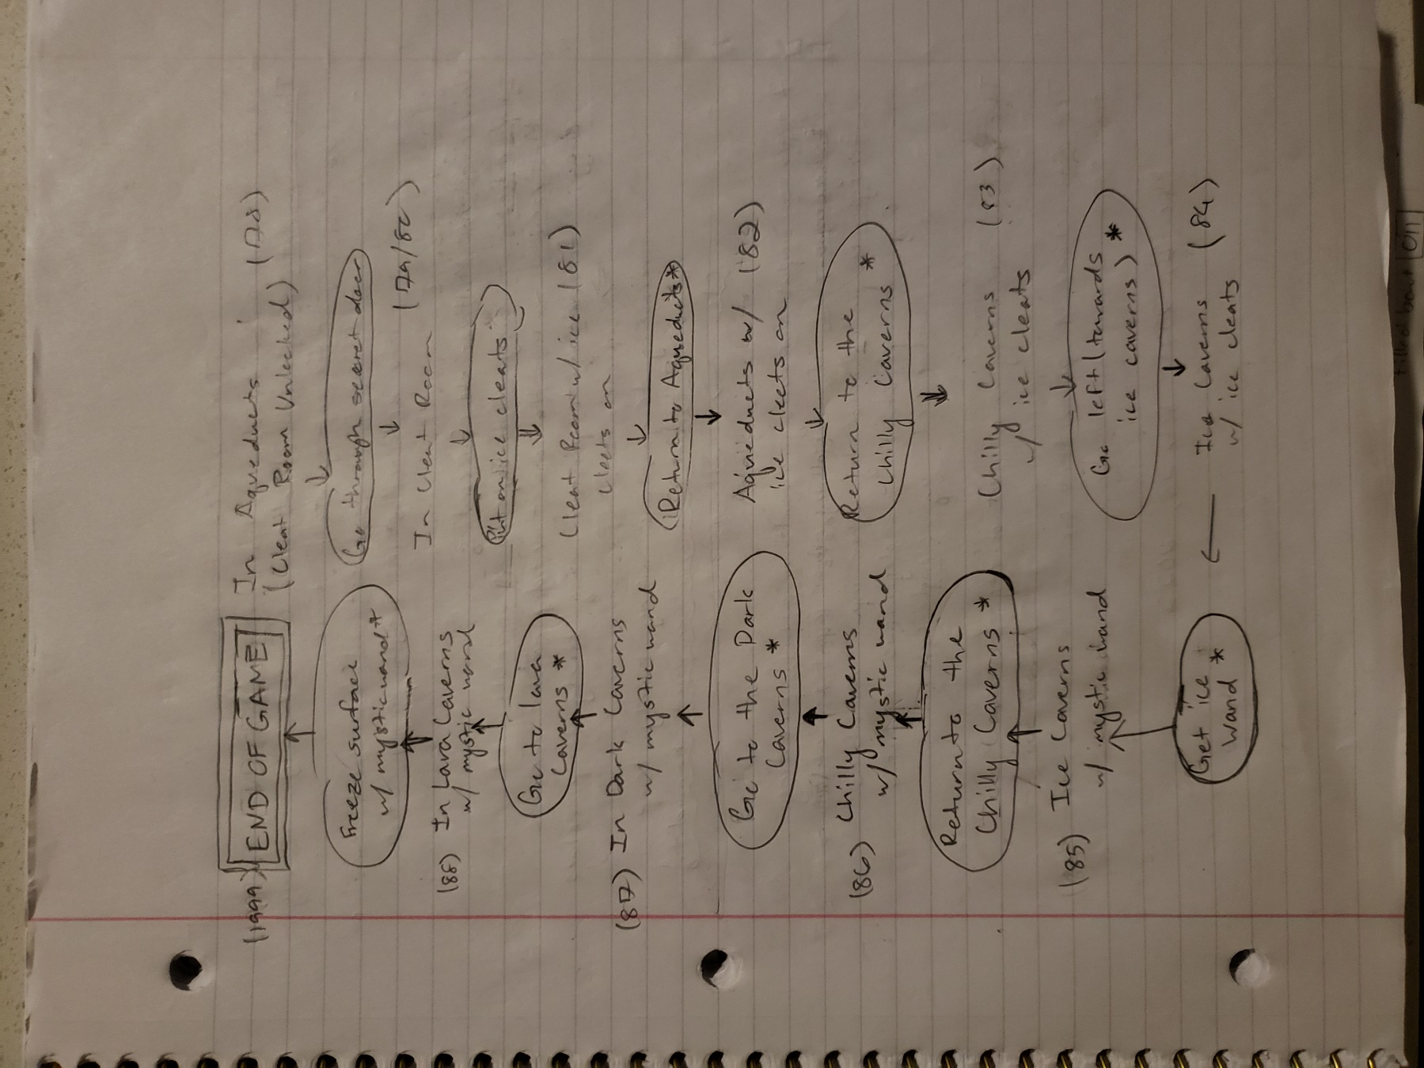

**Interfaces**

The following are two example draft screens compared with screenshots from the final program. Note that the screenshots of the final version of Text-to-Speech Adventure have been taken with the application’s settings configured to where the font size is 24, the font is Consolas, the screen text is black, and the screen background is white.

Draft Screens

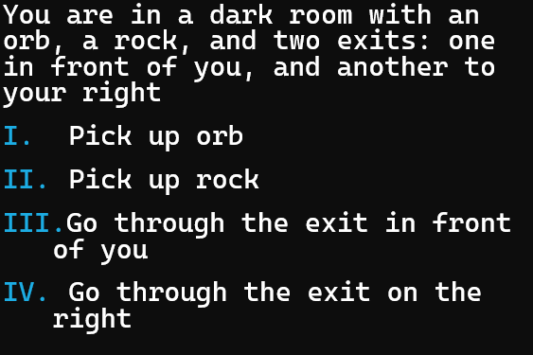

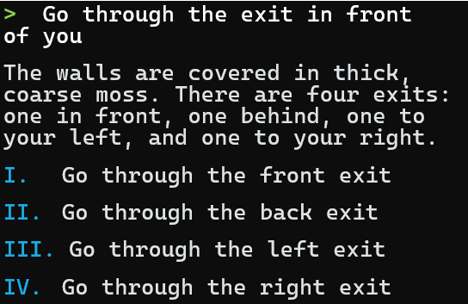

Final Screens

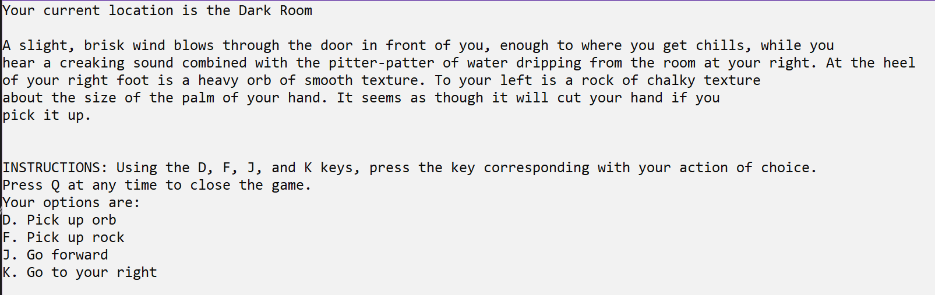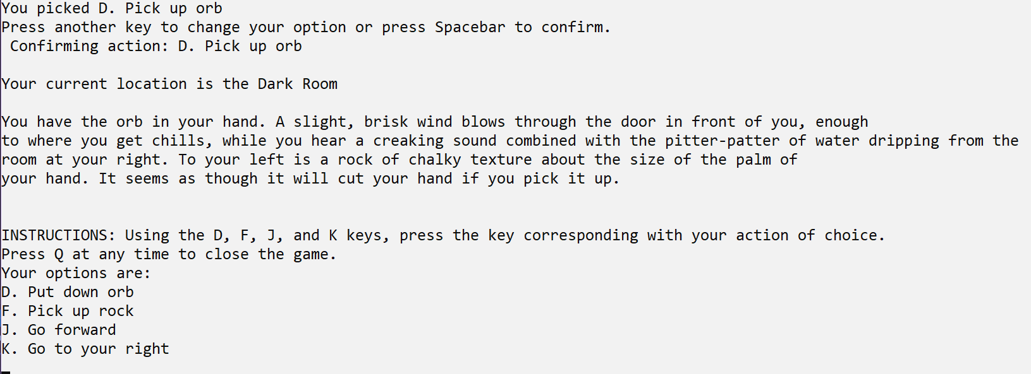

Installation

The following section consists of instructions for developer and user setup of Text-to-Speech Adventure on a Windows 10 machine.

**Developer Tools and Source Code Files**

Go to the following links to download the tools used to develop Text-to-Speech Adventure:

To download Visual Studio 2019: <https://visualstudio.microsoft.com/vs/older-downloads/>

To download SQL Server Management Studio 2018: <https://docs.microsoft.com/en-us/sql/ssms/release-notes-ssms?view=sql-server-ver15#previous-ssms-releases>

Setting up the development environment in Visual Studio:

The source code files of the game are **GameController.cs, RoomNavigation.cs,** and **Room.cs**. To put the source code files in a new project, launch Visual Studio 2019 and start a new project. A variation of the following window should appear:

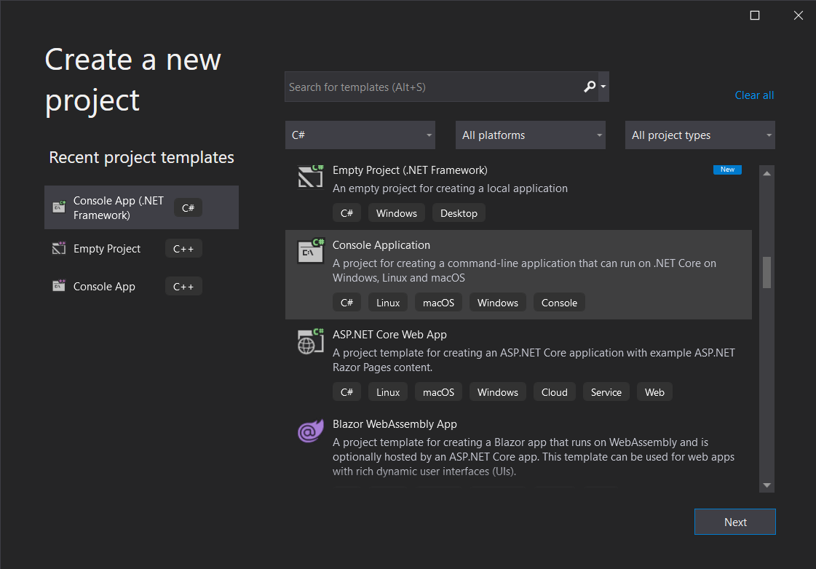

As in the above screen, create a new **C# Console Application.** Visual Studio will then prompt you to name your project. I recommend the developer to name the project **“Text-to-Speech Adventure”** to make it easier to find on the machine.

After the project has been created, the Visual Studio interface should be displayed. At the top of the window, go to **View > Solution Explorer** to open the Solution Explorer (alternatively, you can press Ctrl + Alt + L to open it).

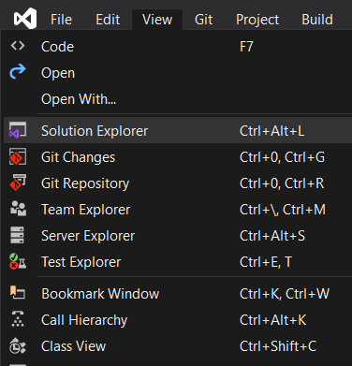

The Solution Explorer should appear on the right side of the screen. In the Solution Explorer, right click the name of the project, and go to **Add > Existing Item** (alternatively, you can press Shift + Alt + A).

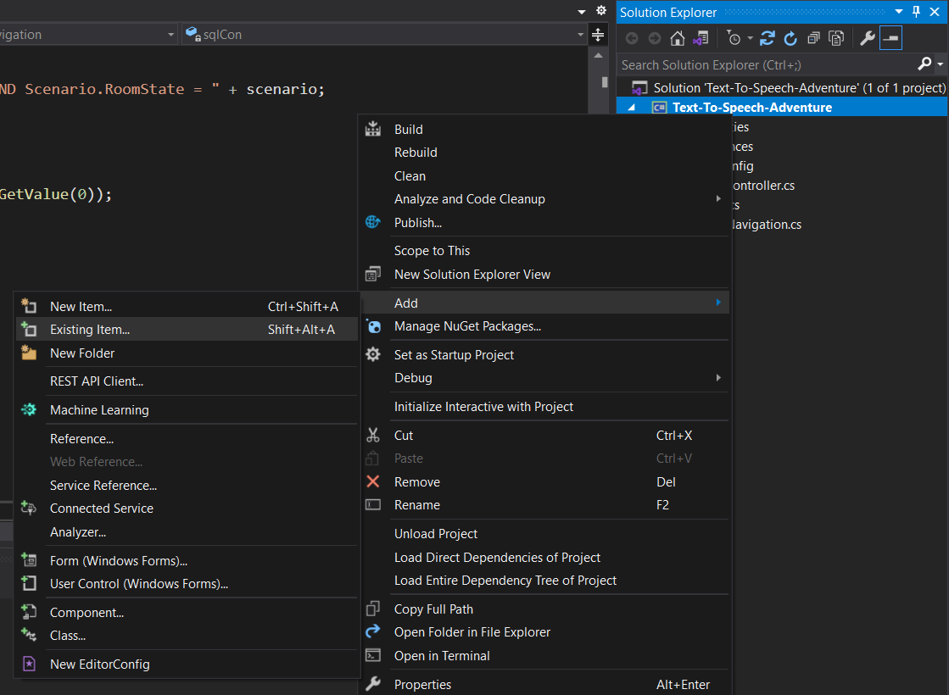

This should open File Explorer on your machine. Select the **GameController.cs, RoomNavigation.cs,** and **Room.cs** files to add them to the project environment.

Setting up the Room Database:

Text-to-Speech Adventure includes code that queries to a database local to the machine. To import the Room Database on your local machine, follow the instructions in this link: <https://docs.microsoft.com/en-us/sql/integration-services/import-export-data/start-the-sql-server-import-and-export-wizard?view=sql-server-ver15>

**Installing for a User**

Text-to-Speech Adventure has not been published. To receive the game, the user must contact me for a .zip file containing the application. Upon receiving **Text-to-Speech Adventure.zip**, extract the files using Windows 10’s built in file extractor (Right click on the .zip file > Extract All…).

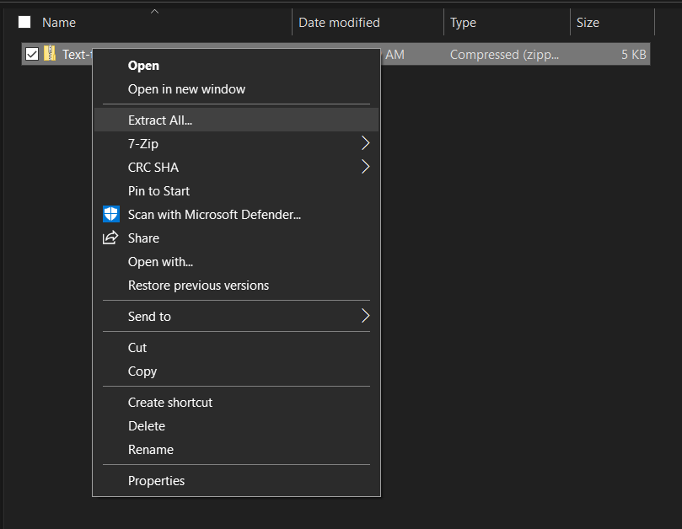

Once extracted, a new folder titled **Text-to-Speech Adventure** will be visible. Within that folder is a file named **Text-to-Speech Adventure.exe.** This is the game itself.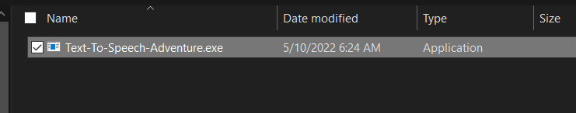

Click on the file to launch the game.

Turning on Microsoft Narrator:

To ensure that Text-to-Speech Adventure accommodates for visually impaired and blind players, the game is compatible with Microsoft Narrator, the built-in text-to-speech program on Windows 10.

The simplest method of turning on Microsoft Narrator is to press the **Windows, Ctrl, and Enter Keys** at the same time. Windows should then give you further instructions on how to use the Narrator program:

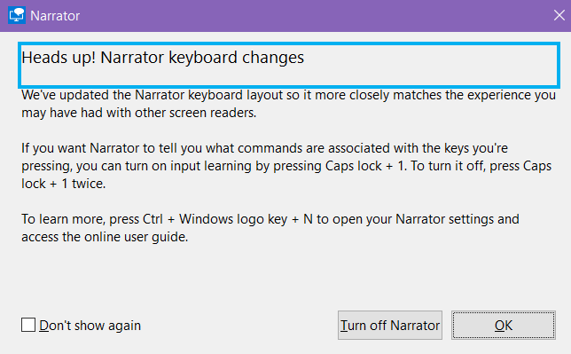

There are two alternative methods of turning on Narrator:

• Type in “narrator” in the Windows Search box and then click “Open”, OR…

• Launch the Start Menu, click “Settings”, click “Ease of Access”, click “Narrator” on the sidebar, then turn on Narrator.

Setting up the Room Database:

Text-to-Speech Adventure includes code that queries to a database local to the machine. To import the Room Database on your local machine, contact me for an exported version of the database and follow the instructions in this link: <https://docs.microsoft.com/en-us/sql/integration-services/import-export-data/start-the-sql-server-import-and-export-wizard?view=sql-server-ver15>

Sample Sessions

This section will include sample sessions involving a user quitting the game upon launch (the quitting functionality), a user pressing the wrong input (input validation), a user going through all options before selecting a preferred option (option confirmation), and the user picking up items exploring the first three rooms that make up the first puzzle (a glimpse of casual gameplay).

Each screenshot will have a description *after* it explaining the current situation.

**Quitting the Game**

Here the user will launch the game and then immediately quit the game using a keyboard command:

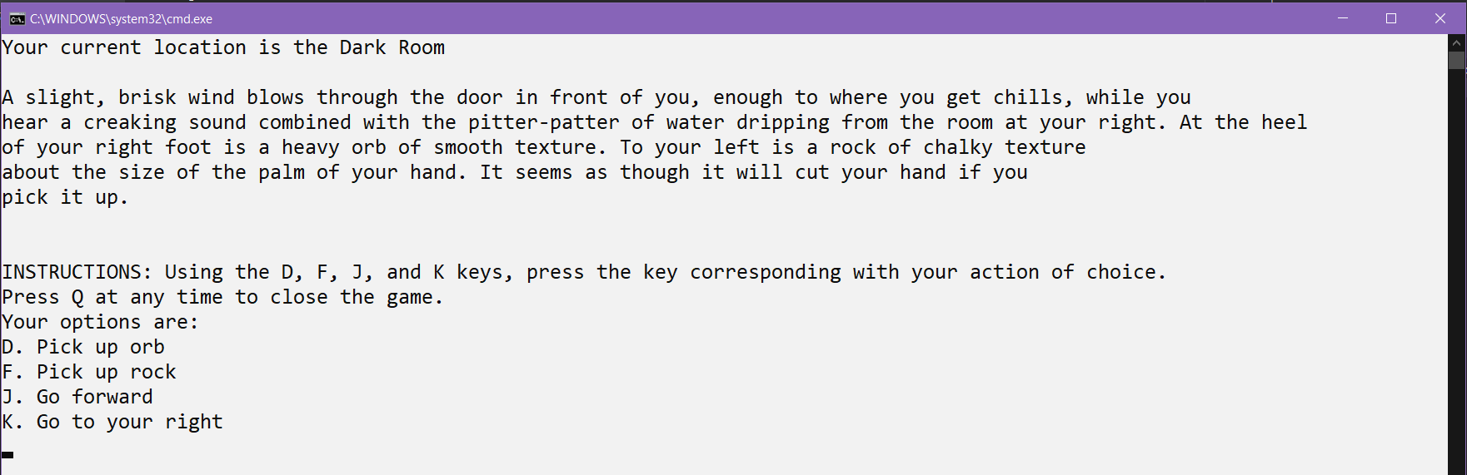

The player is in the first scenario of the game. The game reads all text displayed, which includes the current room, description, instructions, and options.

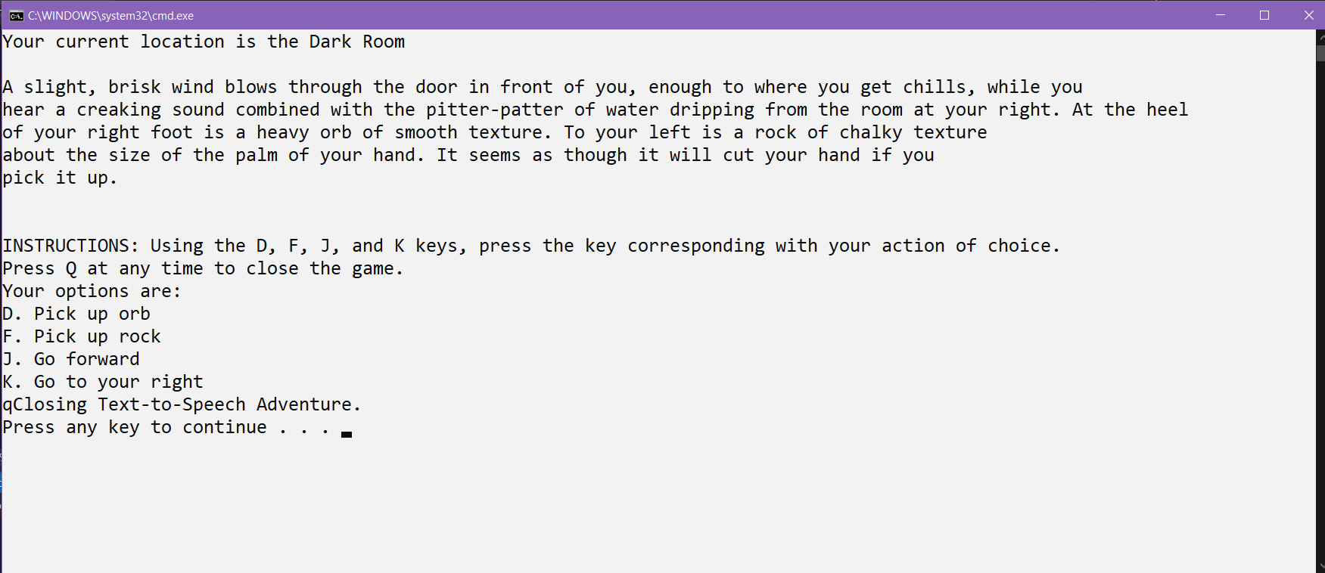

The player press Q. The game notifies the player, and will close once the player presses any key.

**Pressing the Wrong Input**

Here the user will launch the game and then enter an invalid input.



The player is in the first scenario of the game. The game reads all text displayed, which includes the current room, description, instructions, and options.

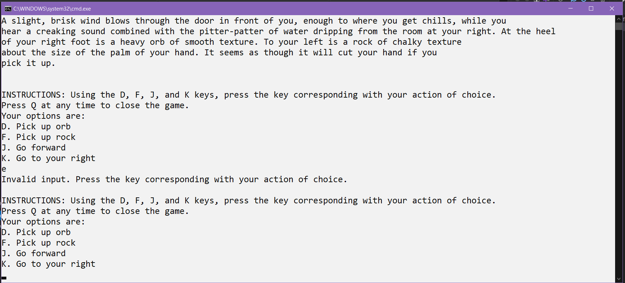

The player presses E, which is an invalid input. The game notifies the player, then repeats the instructions and options.

**Choosing and Confirming an Option**

Here the user will launch the game and try all options before confirming their final choice.



The player is in the first scenario of the game. The game reads all text displayed, which includes the current room, description, instructions, and options.

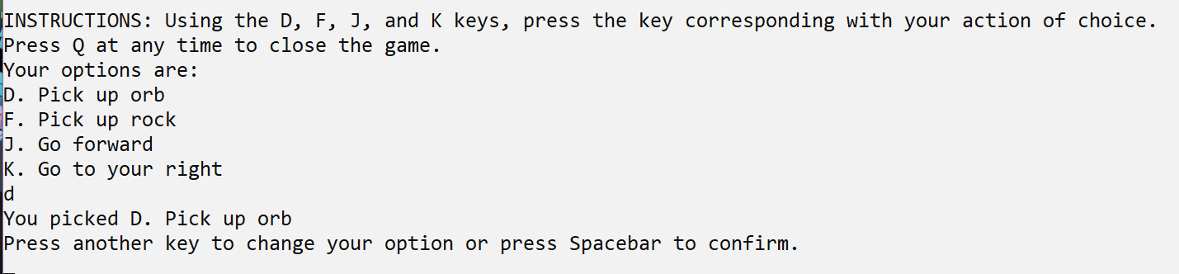

The player picks D to pick up the orb. The game tells the player that they can change their option or press the Spacebar to confirm their choice.

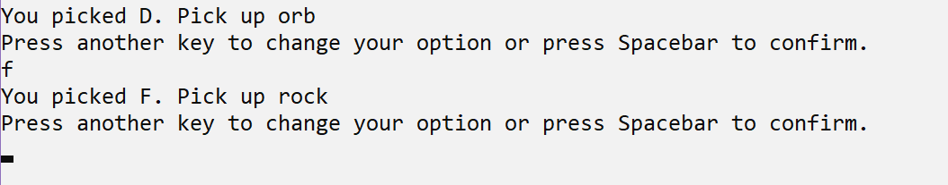

The player picks F to change their choice to “Pick up rock”. The game tells the player that they can change their option or press the Spacebar to confirm their choice.

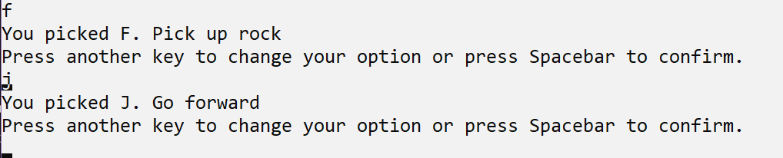

The player picks J to change their choice to “Go forward”. The game tells the player that they can change their option or press the Spacebar to confirm their choice.

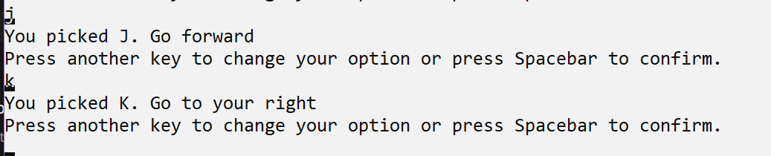

The player picks K to change their choice to “Go to your right”. The game tells the player that they can change their option or press the Spacebar to confirm their choice.

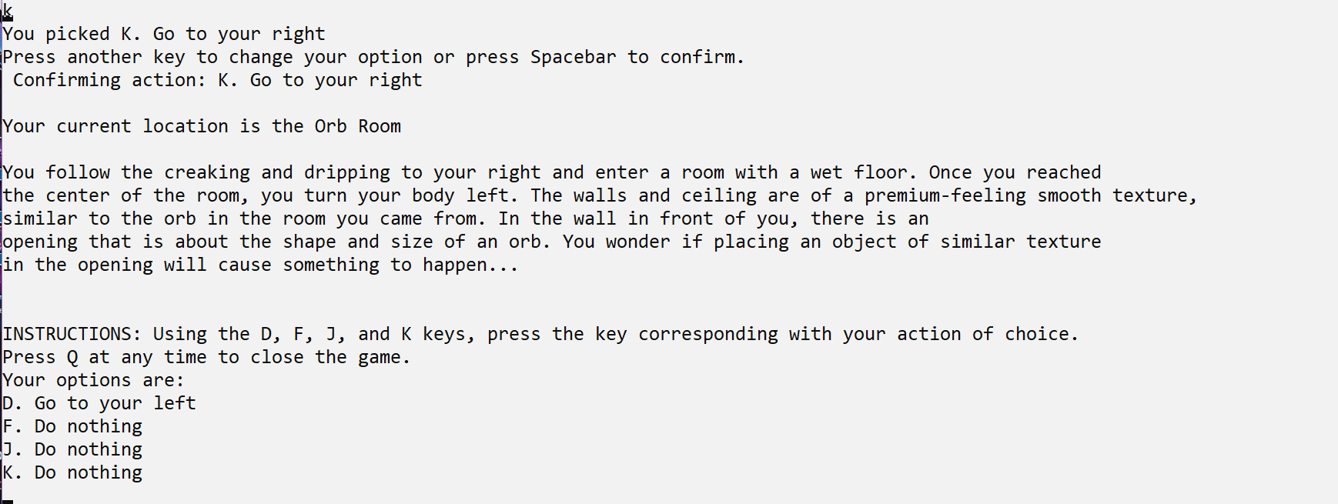

The player presses Spacebar to confirm their choice. The scenario updates with a new room, scenario description, and options the player can choose from.

**Exploring the First Puzzle**

Here the user will pick up a items and explore the three rooms that make up the first puzzle. The player confirms every action they choose in this session. This session ends with the player in the starting Dark Room with both the rock and orb in their hands.



The player is in the first scenario of the game. The game reads all text displayed, which includes the current room, description, instructions, and options.

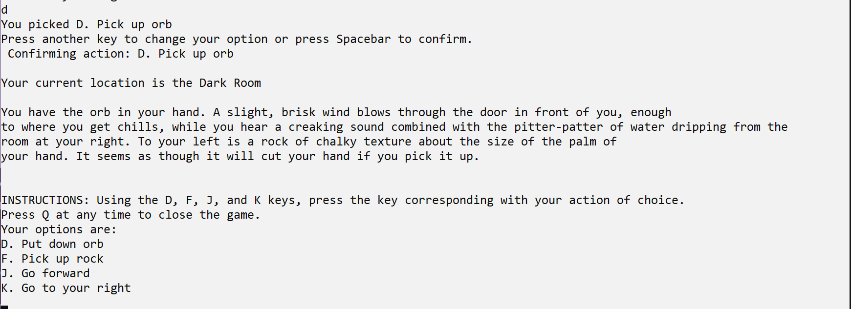

The player presses D to pick up the orb. The scenario updates to show that the player has the orb in their hand. A new set of options is displayed.

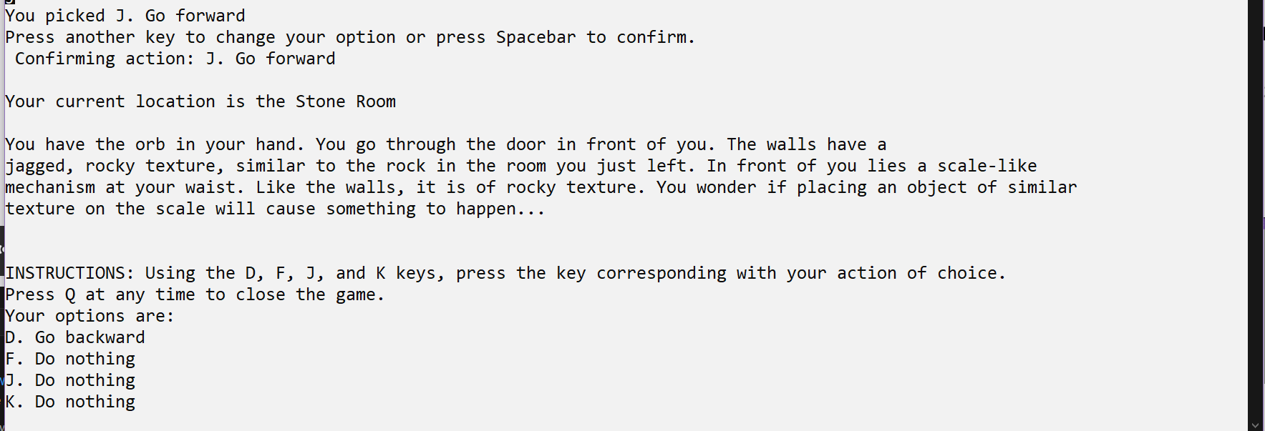

The player presses J to go forward. The scenario updates to show that the player is in the Stone Room with the orb still in their hand. A new set of options is displayed.

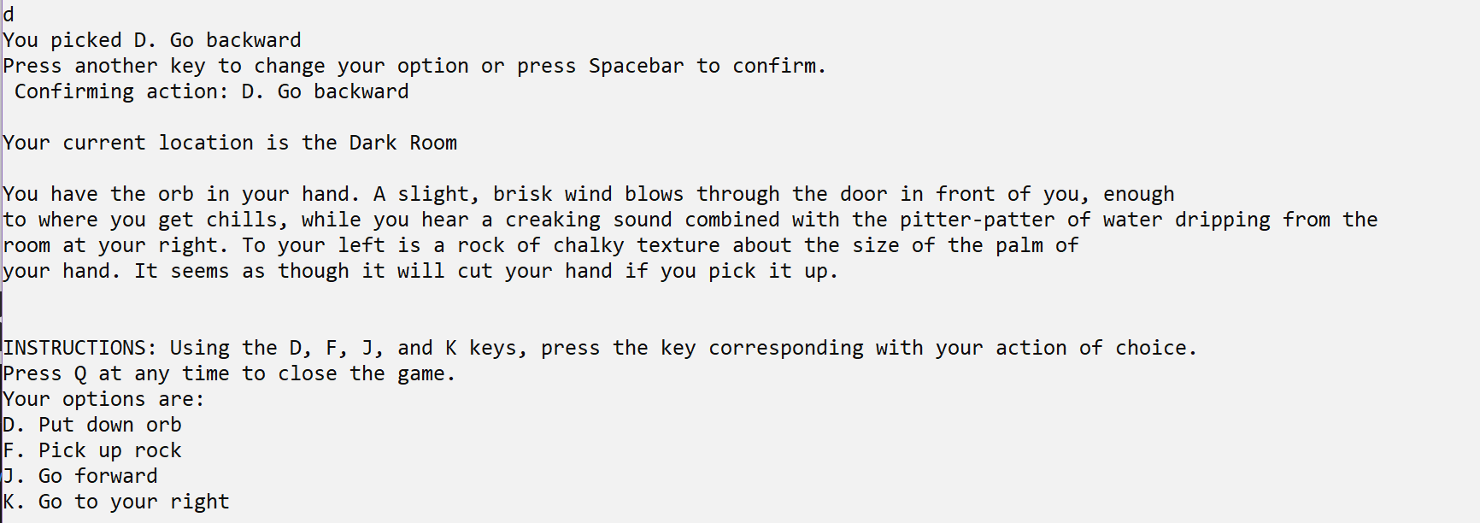

The player presses D to go backward. The scenario updates to show that the player is back in the previous Dark Room with the orb still in their hand. A new set of options is displayed.

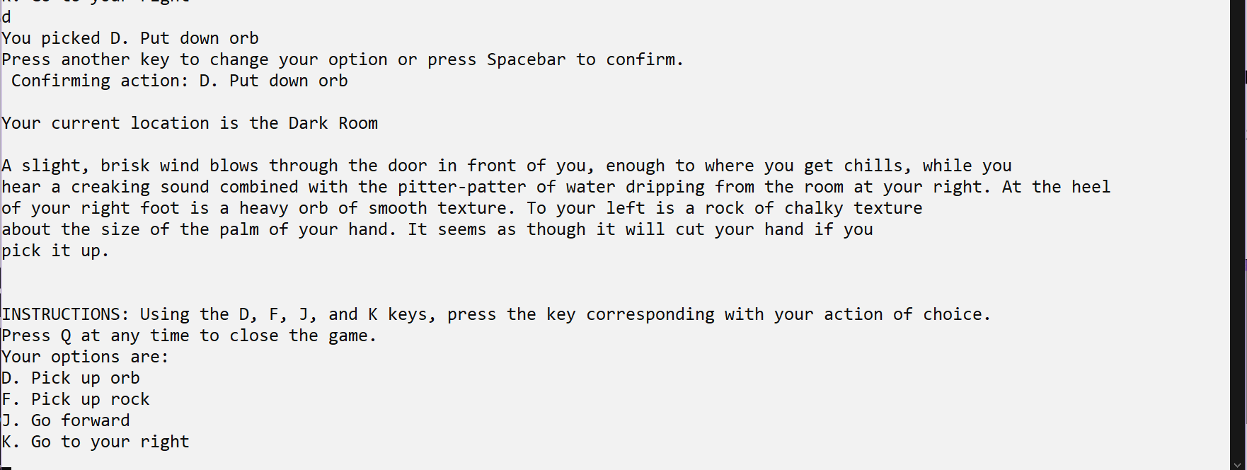

The player presses D to put down the orb. The scenario updates to show that the player no longer has the orb in their hand. A new set of options is displayed.

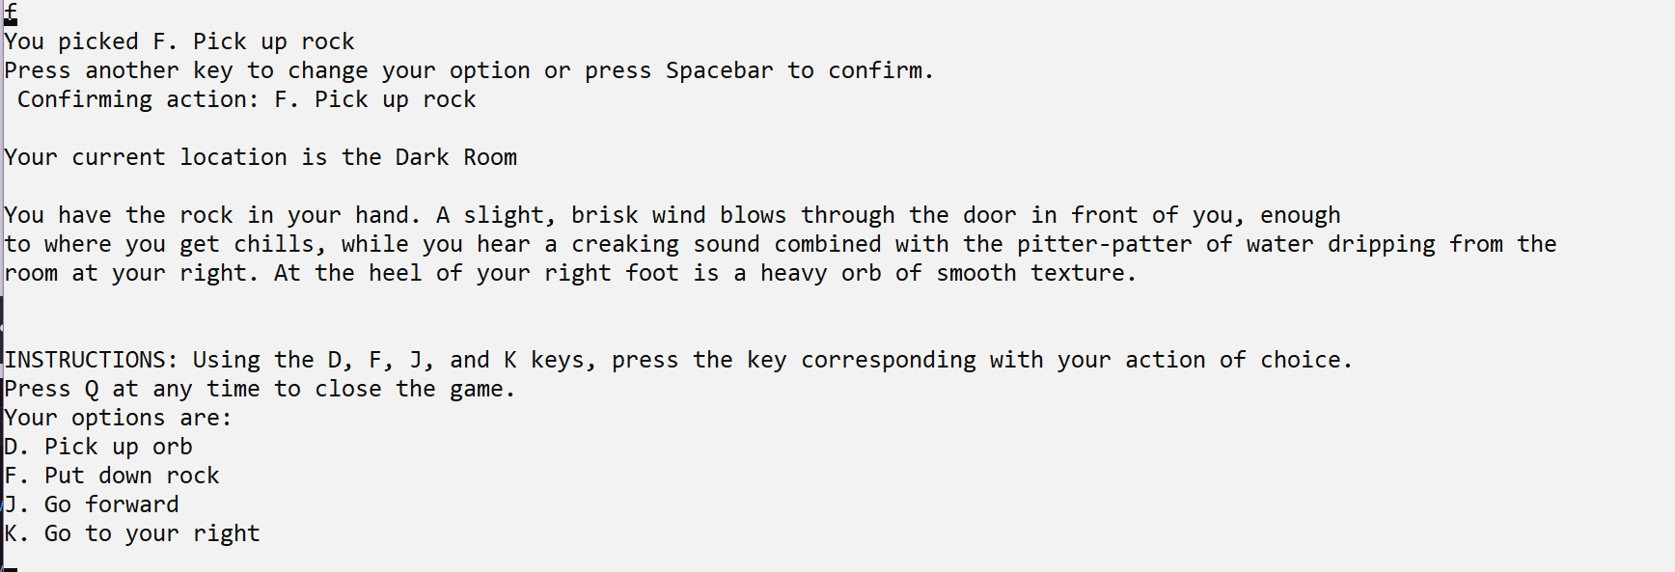

The player presses F to pick up the rock. The scenario updates to show that the player has the rock in their hand. A new set of options is displayed.

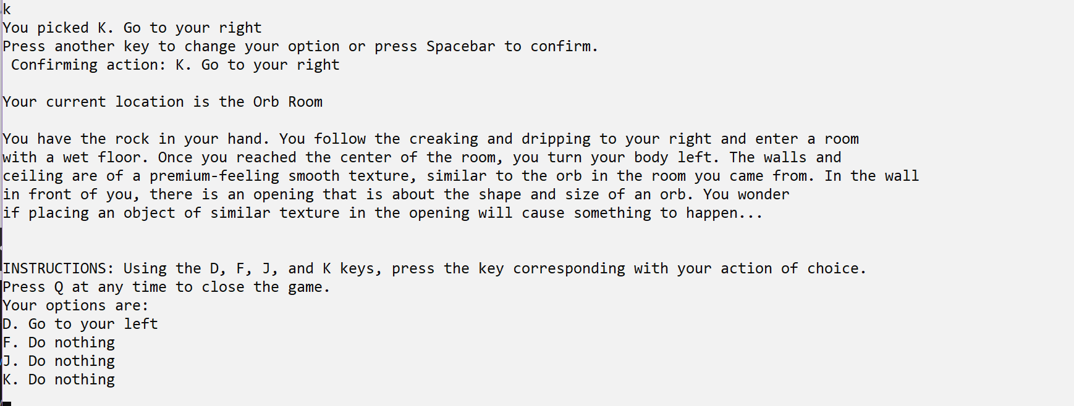

The player presses K to go to their right. The scenario updates to show that the player is in the Orb Room with the rock still their hand. A new set of options is displayed.

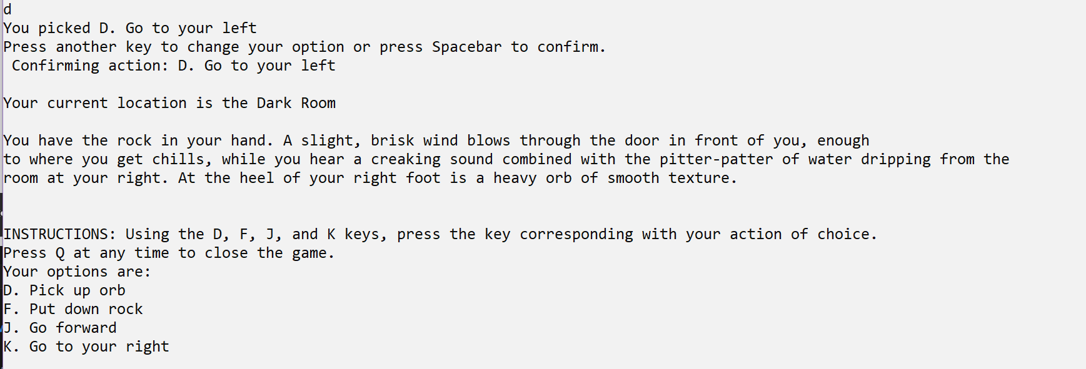

The player presses D to go to their right. The scenario updates to show that the player is back in the previous Dark Room with the rock still in their hand. A new set of options is displayed.

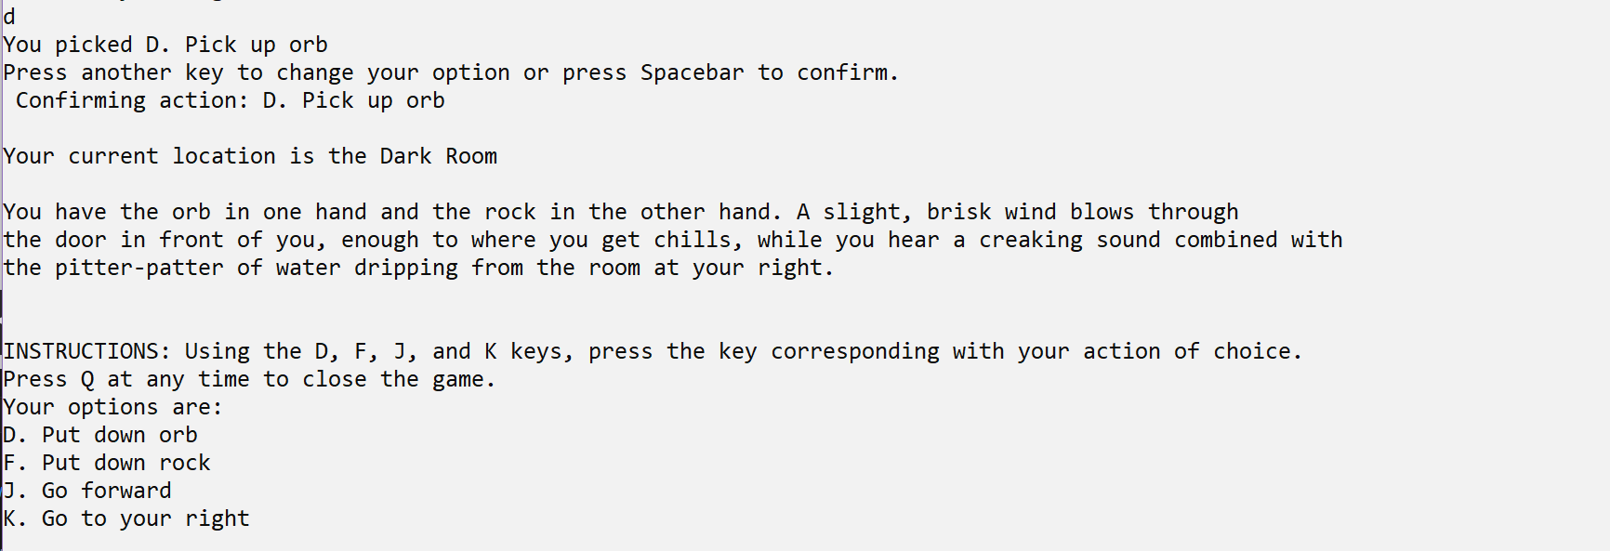

The player presses D to pick up the orb. The scenario updates to show that the player has both the orb and the rock in their hands. A new set of options is displayed. This marks the end of this session.

Troubleshooting

This section outlines potential issues the user may run into when using Text-to-Speech Adventure.

The following table shows errors that you might encounter using this product and suggests how to address each one.

|  |  |  |
| --- | --- | --- |
| Problem/Symptom | Possible Cause(s) | Solutions |
| Game freezes | Corrupted game file  Too many background processes | If possible, close the game.  If the game refuses to close, force close it by going to Task Manager and end the task titled **Text-to-Speech Adventure (32- bit)**  If, for some reason, Windows cannot close the task, restart your computer.  After restarting, relaunch Text-to-Speech Adventure to see if the problem has resolved.  If the problem persists, contact the developer’s email on the cover page of this manual for a new .zip file of the game |
| Game not launching | Corrupted game file | Restart your computer. After restarting, try to launch Text-to-Speech Adventure.  If the problem persists, contact the developer’s email on the cover page of this manual for a new .zip file of the game |
| Keyboard input not being registered | Game window not highlighted  Bug in your version of the game  Keyboard drivers not working | Check if the game’s window is highlighted on your machine and you are not using another application.  If the problem persists, contact the developer’s email on the cover page of this manual for a new .zip file of the game.  If the problem *still* persists, you may need to update/rollback your keyboard’s drivers. |
| Room descriptions not displayed | Room Database not imported on to your machine  Bug in your version of the game | Check to see if you have the Room Database imported on to your machine by doing a system wide search in File Explorer.  If the Room Database connect be found, contact the developer’s email on the cover page of this manual for an exported version of the Room Database.  If the Room Database is on your machine and the problem persists, contact the developer’s email on the cover page of this manual for a new .zip file of the game. |
| Text being read too slow/fast | Narrator settings not to your preference | Type in “narrator settings” in the Windows Search Box, then click “Open”.  Once the Narrator Settings window opens, scroll down to **Personalize Narrator’s voice** and adjust the “Change voice speed” setting to your liking. |
| Text not being read | Narrator turned off  Game window not highlighted  Room descriptions not displayed | Press **Ctrl + Windows + Enter** to toggle Narrator on/off.  If Narrator is on, check if the game’s window is highlighted.  If you are visually impaired and cannot read the text that should be displayed on screen, it is possible that the text is not being displayed. Go to the “Room descriptions not displayed” problem on previous page for guidance. |

References

“Accessible Player Experiences (APX).” *Accessible.Games - Home of APX*, The AbleGamers Foundation Inc., 2021, accessible.games/accessible-player-experiences/. Accessed 10 Jan. 2022.

Brown, Mike. “Gaming for Everyone: The Accessibility Features of Forza Horizon 5.” *Xbox Wire*, Microsoft, 4 Nov. 2021, news.xbox.com/en-us/2021/11/04/gaming-for-everyone-the-accessibility-features-of-forza-horizon-5/. Accessed 10 Jan. 2022.

“C# Docs - Get Started, Tutorials, Reference.” *Microsoft.com*, 2019, docs.microsoft.com/en-us/dotnet/csharp/. Accessed 12 Jan. 2022.

“Download SQL Server Management Studio (SSMS) - SQL Server Management Studio (SSMS).” *Docs.microsoft.com*, Microsoft, 8 Dec. 2021, docs.microsoft.com/en-us/sql/ssms/download-sql-server-management-studio-ssms?view=sql-server-ver15. Accessed 11 Jan. 2022.

“Employer Costs for Employee Compensation News Release Text.” *Www.bls.gov*, U.S. Bureau of Labor Statistics, 17 Dec. 2021, www.bls.gov/news.release/ecec.nr0.htm. Accessed 11 Jan. 2022.

Frank, Allegra. “Nintendo Thanks Blind Fan for His Support in a Touching Note.” *Polygon*, Vox Media, 22 May 2017, www.polygon.com/2017/5/22/15675630/nintendo-blind-fan-letter-rhythm-heaven. Accessed 10 Jan. 2022.

“GanttProject: Free Project Management Tool for Windows, MacOS and Linux.” *GanttProject*, GanttProject, www.ganttproject.biz/download/upgrade. Accessed 11 Jan. 2022.

“GET LAMP: The Text Adventure Documentary.” *Www.youtube.com*, Google TechTalks, 10 Mar. 2011, www.youtube.com/watch?v=LRhbcDzbGSU. Accessed 22 Dec. 2021.

“Hear Text Read Aloud with Narrator.” *Support.microsoft.com*, Microsoft, 2022, support.microsoft.com/en-us/windows/hear-text-read-aloud-with-narrator-040f16c1-4632-b64e-110a-da4a0ac56917. Accessed 10 Jan. 2022.

“HP Pavilion 15Z-CW100 15.6" 16GB 256GB AMD Ryzen 7 3700U, Mineral Silver (Certified Refurbished).” *Walmart.com*, Walmart, 2022, www.walmart.com/ip/HP-Pavilion-15Z-CW100-15-6-16GB-256GB-AMD-Ryzen-7-3700U-Mineral-Silver-Certified-Refurbished/220323746. Accessed 11 Jan. 2022.

“Microsoft SQL Documentation - SQL Server.” *Docs.microsoft.com*, 2022, docs.microsoft.com/en-us/sql/?view=sql-server-ver15. Accessed 12 Jan. 2022.

Pressman, Roger. *Software Engineering*. 9th ed., Mcgraw-Hill, New York NY, 2020.

“Pricing · Plans for Every Developer.” *GitHub*, GitHub, Inc., 2022, github.com/pricing. Accessed 10 Jan. 2022.

“Register as an App Developer – Windows App Development.” *Developer.microsoft.com*, Microsoft, 2022, developer.microsoft.com/en-us/microsoft-store/register/. Accessed 10 Jan. 2022.

Spohn, Steven. “Steve Spohn: My Last Good Day.” *Abilities.com*, Abilities.com, 2022, www.abilities.com/community/last-good-day.html. Accessed 10 Jan. 2022.

Stoner, Grant. “How Xbox Is Advancing Gaming Accessibility on Its Platforms, And, Hopefully, throughout the Industry.” *IGN*, IGN Entertainment Inc., 12 Nov. 2021, www.ign.com/articles/xbox-gaming-accessibility-advancements-controllers-ui. Accessed 10 Jan. 2022.

Tilley, Scott. *System Analysis and Design*. 12th ed., Cengage Learning, Boston, MA. 2019.

“The AbleGamers Charity | the Worlds Largest Charity for Gamers with Disabilities.” *The AbleGamers Charity*, The AbleGamers Foundation Inc., 2021, ablegamers.org/. Accessed 10 Jan. 2022.

“Visual Studio 2019 Release Notes.” *Docs.microsoft.com*, Microsoft, 11 Jan. 2022, docs.microsoft.com/en-us/visualstudio/releases/2019/release-notes. Accessed 11 Jan. 2022.

“Visual Studio IDE Documentation.” *Docs.microsoft.com*, 2022, docs.microsoft.com/en-us/visualstudio/ide/?view=vs-2022. Accessed 12 Jan. 2022.

Whitehead, Thomas. “Steven Spohn on Strides in Accessibility for Gaming, and Nintendo’s Room for Improvement.” *Nintendo Life*, Hookshot Media, 30 Dec. 2021, www.nintendolife.com/features/steven-spohn-on-strides-in-accessibility-for-gaming-and-nintendos-room-for-improvement. Accessed 10 Jan. 2022.

“Xbox Adaptive Controller | Xbox.” *Xbox.com*, Microsoft, 2022, www.xbox.com/en-US/accessories/controllers/xbox-adaptive-controller. Accessed 12 Dec. 2021.

Source Code File Listings

**GameController.cs**

/*******************************************************************************************

* Text-to-Speech Adventure by Mujeeb Adelekan

* Last updated: May 8, 2022

* Senior Project for St. Mary's University's B.S. Program in Computer Science

******************************************************************************************/

// C# 'using' directives

using System;

using System.Collections.Generic;

using System.Data.SqlClient;

// ********* GameController Class **********

namespace Text_To_Speech_Adventure

{

class GameController

{

/*** GameController Attributes ***/

// made static so that ALL instances of GameController share the same variables

static RoomNavigation roomNavigation; // a reference to the RoomNavigation class

static List<string> actionLog = new List<string>(); // list of actions the user has taken

static SqlConnection sqlCon; // represents connection to SQL Server database

/*** GameController Methods ***/

// Main()

static void Main(string[] args)

{

// ********************************** Connect to SQL Server ********************************************

/* Connection String syntax:

* For Windows auth.

* @"Data Source=(MachineName)\(InstanceName);Initial Catalog=(DBName);Integrated Security=True;"

*/

sqlCon = new SqlConnection(@"Data Source=localhost\SQLEXPRESS;Initial Catalog=Room Database;Integrated Security=True;");

// ***************************** Create a new roomNavigation object *******************************************

roomNavigation = new RoomNavigation();

// ***************************** Initialize Starting Room *****************************************************

roomNavigation.currentRoom = new Room();

// set up connection

sqlCon.Open();

/*** get room description ***/

// write SQL command for the room description

string cmdText = "SELECT Description FROM Scenario WHERE RoomState = 0";

SqlCommand command = new SqlCommand(cmdText, sqlCon);

//send the command text to the sql connection, and build a SqlDataReader

SqlDataReader dataReader = command.ExecuteReader();

while (dataReader.Read())

{

roomNavigation.currentRoom.setDescription((string)dataReader.GetValue(0));

}

dataReader.Close(); //close the current data reader

/*** get room name ***/

cmdText = "SELECT Room.Name " +

"FROM Room, Scenario " +

"WHERE Room.RoomID = Scenario.RoomID AND Scenario.RoomState = 0";

command = new SqlCommand(cmdText, sqlCon);

dataReader = command.ExecuteReader();

while (dataReader.Read())

{

roomNavigation.currentRoom.setRoomName((string)dataReader.GetValue(0));

}

dataReader.Close();

//Display the room's text

var ctrl = new GameController();

ctrl.AddRoomDescriptionToActionLog();

ctrl.DisplayLoggedText();

/*** display the options of the current scenario ***/

roomNavigation.DisplayOptionsForCurrentScenario(0); //zero corresponds to the starting scenario

Console.WriteLine(); //newline

//close the connection

sqlCon.Close();

}

// DisplayLoggedText(): display the current content of the action log

public void DisplayLoggedText()

{

// join the list of strings into a singluar log

string logAsText = string.Join("\n", actionLog.ToArray());

// split the log into separate words

string[] formattedText = logAsText.Split(' ');

// store each line as an array of words-per-line (wpl) words

int wpl = 20;

string[] line = new string[wpl];

// print wpl words per line so Narrator can read each word in its entirety

for (int i = 0; i < formattedText.Length; i++)

{

line[i % wpl] = formattedText[i];

if ((i % wpl == wpl - 1) || (i == formattedText.Length - 1))

{

Console.WriteLine(string.Join(" ", line));

Array.Clear(line, 0, wpl);

}

}

}

// AddRoomDescriptionToActionLog() (previously named DisplayRoomText()):

// display the current room's description by adding it to the action log

public void AddRoomDescriptionToActionLog()

{

actionLog.Clear();

//add the current room description to the action log

Console.WriteLine("Your current location is the " + roomNavigation.currentRoom.getRoomName() + "\n");

AddToActionLog(roomNavigation.currentRoom.getDescription() + "\n");

}

// AddToActionLog(): add the description of the chosen action to the action log

void AddToActionLog(string actionDescription)

{

actionLog.Add(actionDescription + "\n");

}

//GetSQLConnection(): get access to the SQL server connection

public SqlConnection GetSQLConnection()

{

return sqlCon;

}

}

}

**RoomNavigation.cs**

//C# 'using' directives

using System;

using System.Data.SqlClient;

// ********* RoomNavigation Class **********

namespace Text_To_Speech_Adventure

{

class RoomNavigation

{

/*** RoomNavigation Attributes ***/

public Room currentRoom; //holds the room the player is currently in

GameController controller; // a reference to the GameController class

static int scenario; //current room state the player is in

string[] options = new string[4]; // array that holds the current options the user can perform

SqlConnection sqlCon; // represents connection to SQL Server database

/*** RoomNavigation Methods ***/

// RoomNavigation constructor

public RoomNavigation()

{

currentRoom = new Room();

controller = new GameController();

sqlCon = controller.GetSQLConnection();

}

// DisplayOptionsForCurrentScenario(): print the options for the current scenario (room state)

public void DisplayOptionsForCurrentScenario(int roomState)

{

// initialize scenario upon starting the game

if (roomState == 0)

{

scenario = roomState;

}

// variables used for SQL Queries

string cmdText;

SqlCommand command;

SqlDataReader dataReader;

string optLine; // full option line to be printed

string optDesc = ""; // string representing option description

char key; // key to be pressed

Console.WriteLine("INSTRUCTIONS: Using the D, F, J, and K keys, press the key corresponding with your action of choice.");

Console.WriteLine("Press Q at any time to close the game.");

Console.WriteLine("Your options are:");

for (int i = 1; i <= 4; i++)

{

// write SQL command for the option description

cmdText = "SELECT Opt" + i + "Desc FROM Scenario WHERE RoomState = " + scenario;

command = new SqlCommand(cmdText, sqlCon);

dataReader = command.ExecuteReader();

while (dataReader.Read())

{

optDesc = (string)dataReader.GetValue(0);

}

//Print to terminal

switch (i)

{

case 1:

key = 'D';

break;

case 2:

key = 'F';

break;

case 3:

key = 'J';

break;

case 4:

key = 'K';

break;

default:

throw new ArgumentException("Queried option does not exist");

}

optLine = key + ". " + optDesc;

Console.WriteLine(optLine);

options[i - 1] = optLine;

dataReader.Close();

}

AcceptInput();

}

// AcceptInput(): takes in the integer representation of the option chosen by the user

void AcceptInput()

{

int choice = 0;

ConsoleKeyInfo cki;

do

{

cki = Console.ReadKey(); //read the user's input

switch (cki.Key)

{

case ConsoleKey.D:

choice = 1;

Console.WriteLine("\nYou picked " + options[choice - 1]);

Console.WriteLine("Press another key to change your option or press Spacebar to confirm.");

break;

case ConsoleKey.F:

choice = 2;

Console.WriteLine("\nYou picked " + options[choice - 1]);

Console.WriteLine("Press another key to change your option or press Spacebar to confirm.");

break;

case ConsoleKey.J:

choice = 3;

Console.WriteLine("\nYou picked " + options[choice - 1]);

Console.WriteLine("Press another key to change your option or press Spacebar to confirm.");

break;

case ConsoleKey.K:

choice = 4;

Console.WriteLine("\nYou picked " + options[choice - 1]);

Console.WriteLine("Press another key to change your option or press Spacebar to confirm.");

break;

case ConsoleKey.Spacebar:

if (choice != 0)

{

Console.WriteLine("Confirming action: " + options[choice - 1] + "\n");

}

else

{

Console.WriteLine("\nInvalid input. Press the key corresponding with your action of choice.\n");

DisplayOptionsForCurrentScenario(scenario);

}

break;

case ConsoleKey.Q:

// close the game

Console.WriteLine("Closing Text-to-Speech Adventure.");

Environment.Exit(0);

break;

// Allow the user to change volume and brightness without printing "Invalid Input"

case ConsoleKey.VolumeDown:

case ConsoleKey.VolumeUp:

case ConsoleKey.VolumeMute:

case (ConsoleKey)255: // brightness setting

break;

// CHEAT CODE FOR CS SYMPOSIUM PRESENTATION

case ConsoleKey.Z:

if (scenario == 29) //Arriving in the Dark Caverns

{

Console.WriteLine("Skipping to the Aqueduct Puzzle");

SkipToSecondPuzzle();

}

break;

default:

Console.WriteLine("\nInvalid input. Press the key corresponding with your action of choice.\n");

DisplayOptionsForCurrentScenario(scenario);

break;

}

} while (cki.Key != ConsoleKey.Spacebar);

RespondToInput(choice);

}

// RespondToInput()

void RespondToInput(int action)

{

// variables used for SQL Queries

string cmdText;

SqlCommand command;

SqlDataReader dataReader;

cmdText = "SELECT Opt" + action + "Res FROM Scenario WHERE RoomState = " + scenario;

command = new SqlCommand(cmdText, sqlCon);

dataReader = command.ExecuteReader();

while (dataReader.Read())

{

scenario = (int)dataReader.GetValue(0);

}

dataReader.Close();

// update room description

cmdText = "SELECT Description FROM Scenario WHERE RoomState = " + scenario;

command = new SqlCommand(cmdText, sqlCon);

dataReader = command.ExecuteReader();

while(dataReader.Read())

{

currentRoom.setDescription((string)dataReader.GetValue(0));

}

dataReader.Close();

// update room name

cmdText = "SELECT Room.Name " +

"FROM Room, Scenario " +

"WHERE Room.RoomID = Scenario.RoomID AND Scenario.RoomState = " + scenario;

command = new SqlCommand(cmdText, sqlCon);

dataReader = command.ExecuteReader();

while (dataReader.Read())

{

currentRoom.setRoomName((string)dataReader.GetValue(0));

}

dataReader.Close();

controller.AddRoomDescriptionToActionLog();

controller.DisplayLoggedText();

// determine if the player has finished the game

if (scenario != 1999)

{

DisplayOptionsForCurrentScenario(scenario);

}

else

{

Environment.Exit(0);

}

}

// SkipToSecondPuzzle(): Brings the user to the aqueduct puzzle after the user enters the Dark Caverns

// /*** THIS IS A CHEAT FOR THE CS SYMPOSIUM ***/

void SkipToSecondPuzzle()

{

// set scenario to 35 which will bring the user to the second puzzle

scenario = 35;

// variables used for SQL Queries

string cmdText;

SqlCommand command;

SqlDataReader dataReader;

// update room description

cmdText = "SELECT Description FROM Scenario WHERE RoomState = " + scenario;

command = new SqlCommand(cmdText, sqlCon);

dataReader = command.ExecuteReader();

while (dataReader.Read())

{

currentRoom.setDescription((string)dataReader.GetValue(0));

}

dataReader.Close();

// update room name

cmdText = "SELECT Room.Name " +

"FROM Room, Scenario " +

"WHERE Room.RoomID = Scenario.RoomID AND Scenario.RoomState = " + scenario;

command = new SqlCommand(cmdText, sqlCon);

dataReader = command.ExecuteReader();

while (dataReader.Read())

{

currentRoom.setRoomName((string)dataReader.GetValue(0));

}

dataReader.Close();

controller.AddRoomDescriptionToActionLog();

controller.DisplayLoggedText();

DisplayOptionsForCurrentScenario(scenario);

}

}

}

**Room.cs**

// ********* Room Class (data container class) **********

namespace Text_To_Speech_Adventure

{

class Room

{

string description; // holds room's description

string roomName; // hold room's name

/*** Room Constructors ***/

public Room() { } //general constructor

public Room(string description, string roomName) //explicit constructor

{

setDescription(description);

setRoomName(roomName);

}

/*** Set Methods ***/

public void setDescription(string description)

{

this.description = description;

}

public void setRoomName(string roomName)

{

this.roomName = roomName;

}

/*** Get Methods ***/

public string getDescription()

{

return description;

}

public string getRoomName()

{

return roomName;

}

}

}